Contents

1.0 Introduction 3

1.1. Setting 3

1.2. Scene flow 3

2.0 Project plan 4

2.1. Initial Project Plan 4

2.2. Week 1 8

2.3. Week 2 10

2.4. Week 3 11

2.5. Week 4 12

2.6. Week 5 14

2.7. Week 6 16

3.0 Technical Element - Vectors 17

3.1. Introduction 17

3.2. Uses in Video Games 17

3.2.1. Main uses 17

3.2.2. Movement 17

3.2.3. Distance 18

3.2.4. Other Uses 18

4.0 Script – ItemGrabber.cs 19

5.0 Unique Element – Day / Night Cycle 23

6.0 Summary 23

7.0 Future Work 23

8.0 References 24

8.1. Github 24

8.2. Assets 24

8.2.1. Models 24

8.2.2. Audio 24

8.2.3. Fonts 25

8.2.4. Sprites 25

8.2.5. Scripts 25

8.2.6. Full References 25

9.0 Appendix 30

9.1. Scripts 30

9.1.1. Candle.cs 30

9.1.2. CuckooClock.cs 31

9.1.3. DayNightController.cs 32

9.1.4. Door.cs 34

9.1.5. DoorLockTrigger.cs 36

9.1.6. DoorSounds.cs 36

9.1.7. DoorTexts.cs 37

9.1.8. DoorTrigger.cs 38

9.1.9. EndingTrigger.cs 39

9.1.10. FireBasket.cs 39

9.1.11. InsideHouseController.cs 40

9.1.12. ItemGrabber.cs 41

9.1.13. Key.cs 43

9.1.14. KeyDisplay.cs 44

9.1.15. KeyManager.cs 45

9.1.16. LightBulb.cs 46

9.1.17. Pendulum.cs 47

9.1.18. PianoTrigger.cs 47

9.1.19. Pickup.cs 48

9.1.20. PlayerInputHandler.cs 49

9.1.21. ServingHatchTrigger.cs 50

9.1.22. SpotlightTrigger.cs 51

9.1.23. TVTrigger.cs 51

9.1.24. UIController.cs 52

9.1.25. Vase.cs 53

9.1.26. Wolves.cs 54

# Introduction

## Setting

The scene will start with the player outside in a forest in a perpetual foggy night cycle with a spooky house in front of them, they will then approach the house triggering a floodlight. Upon entering the house the front door will lock and they will have to complete the following steps to escape the house and trigger a daytime cycle, completely changing the mood of the scene

## Scene flow

1. Approach house triggering a floodlight.
2. Enter house and doors lock – loud clock ticking.
3. The cuckoo clock goes off when nearby dropping the cuckoo.
4. Carry the cuckoo upstairs.
5. Enter bedroom, bedroom door locks.
6. Throw the cuckoo in the bedroom fire increasing intensity – A vase appears.
7. Pick up the bathroom key from the bedside table.
8. Exit bedroom via the en-suite bathroom.
9. Throw the vase down the stairs, smashing it to reveal the lounge key.
10. Enter the lounge – the piano starts playing a spooky music loop.
11. Pick up the fruit bowl.
12. Approach the lounge fire – Tv comes on.
13. Throw the fruit bowl in the lounge fire, increasing intensity and melting the candle. – Kitchen key appears.
14. Enter the kitchen – serving hatch doors start clattering
15. Exit the kitchen to the conservatory.
16. Collect the conservatory key from the pool table.
17. Exit conservatory triggering daytime.
18. Display Message – “You escaped!”

# Project plan

## Initial Project Plan

Below is my initial project plan (Figure 2.1) on Trello (Atlassian, 2021) which is available at the following link - <https://trello.com/b/x2qX9eYN/p3d-asignment>.

All expandable cards are also shown below (Figures 2.2 – 2.7)

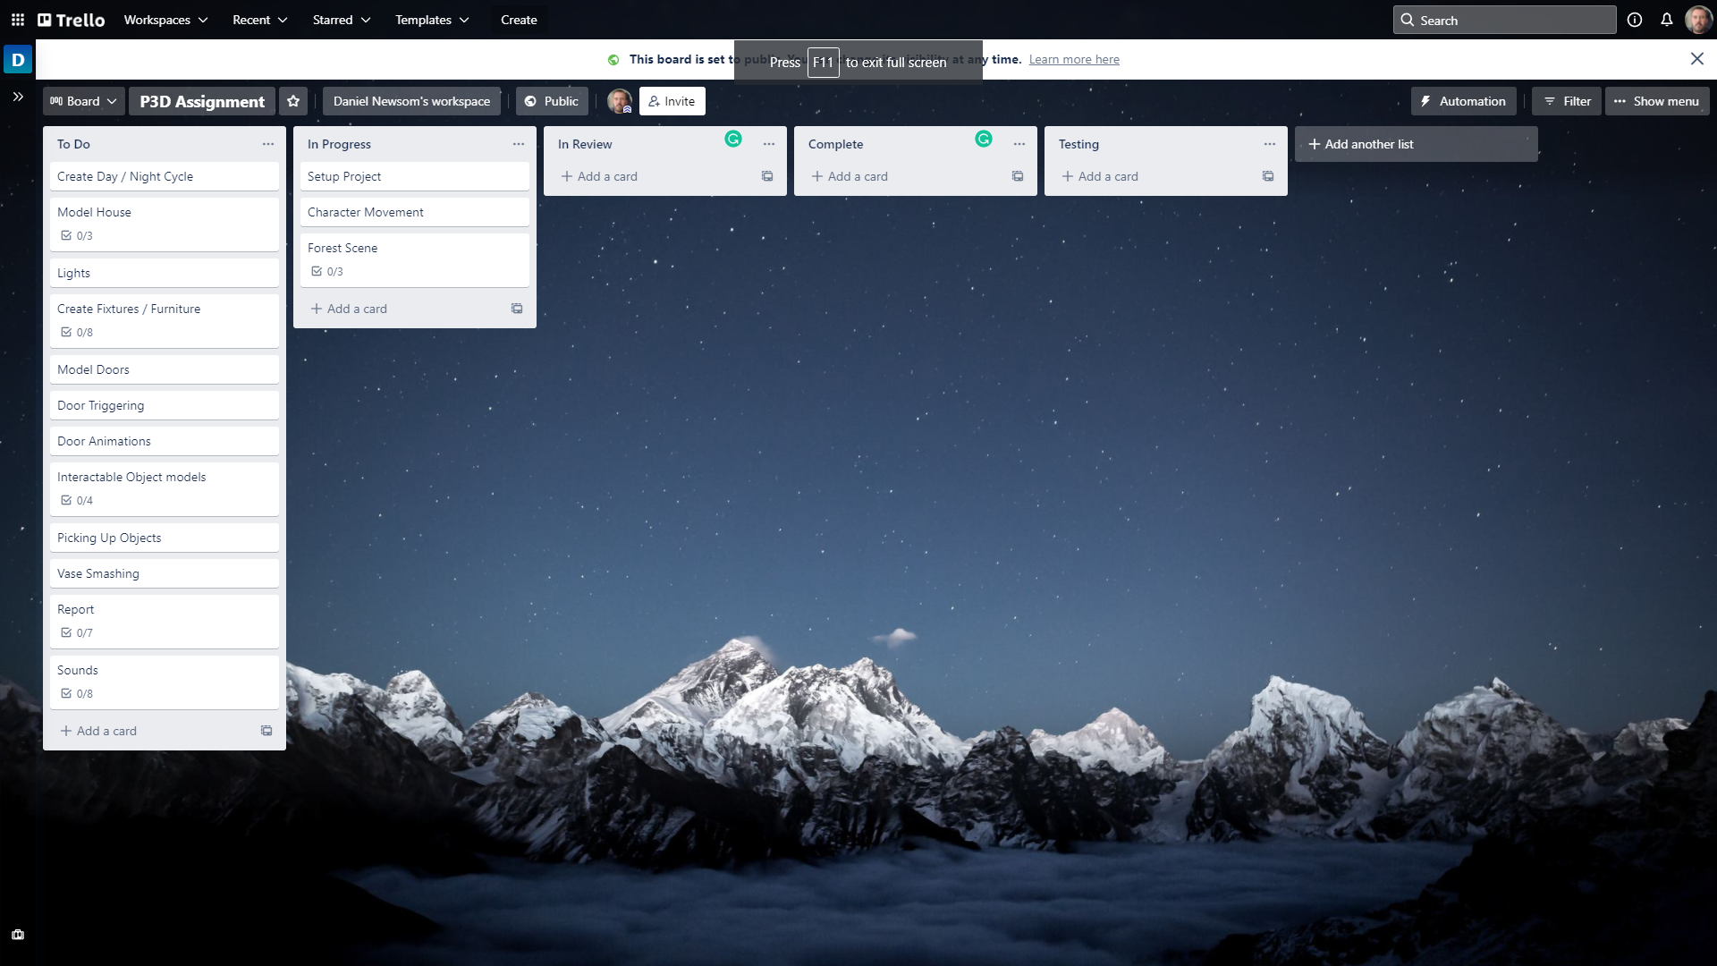

Figure 2.1 – Initial project plan on Trello (Atlassian, 2021)

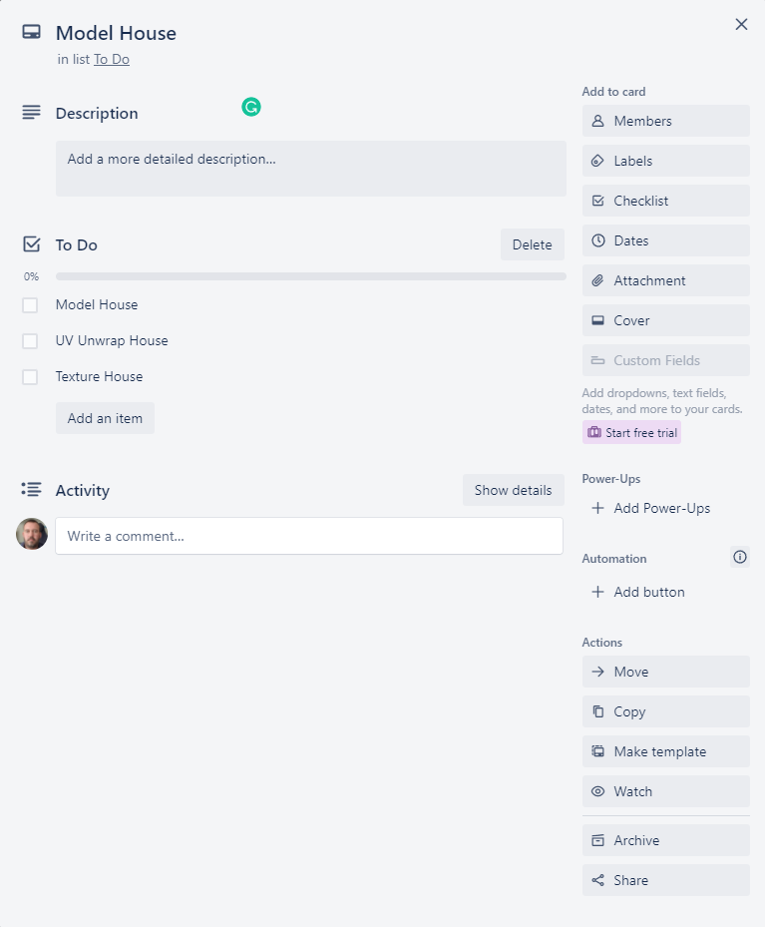

Figure 2.2 – Model house card

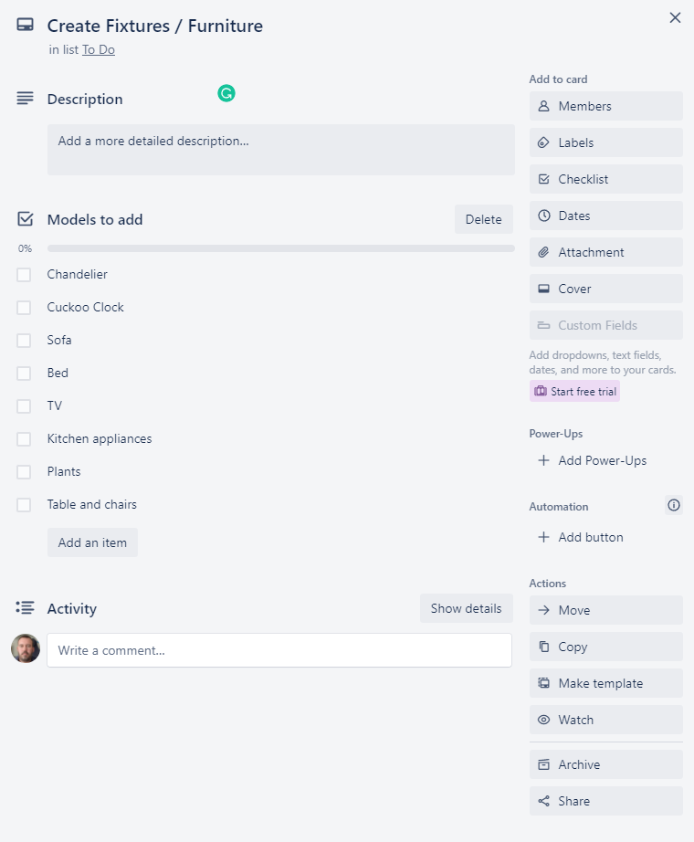

Figure 2.3 – Create Fixtures / Furniture card

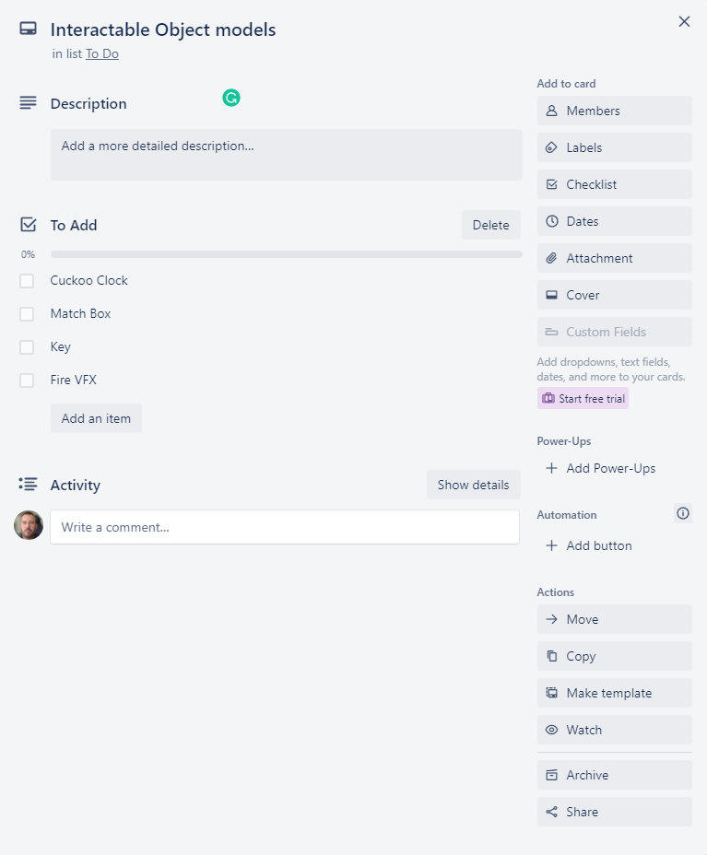

Figure 2.4 – Interactable Object Models card

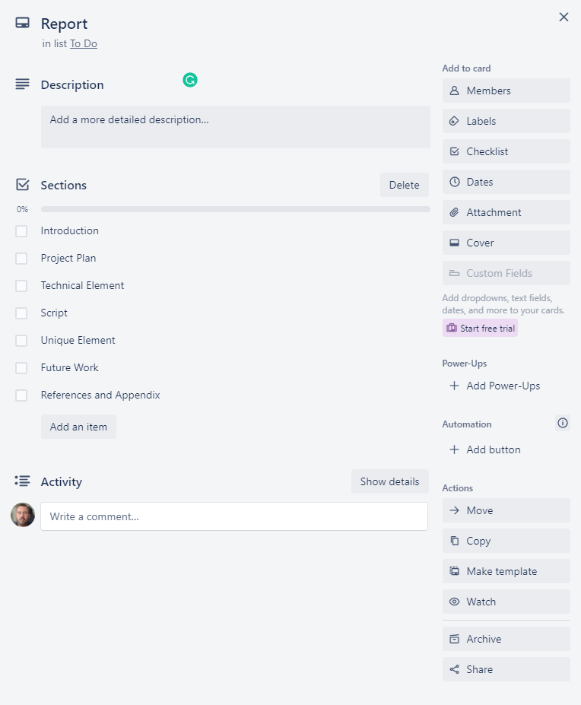

Figure 2.5 – Report card

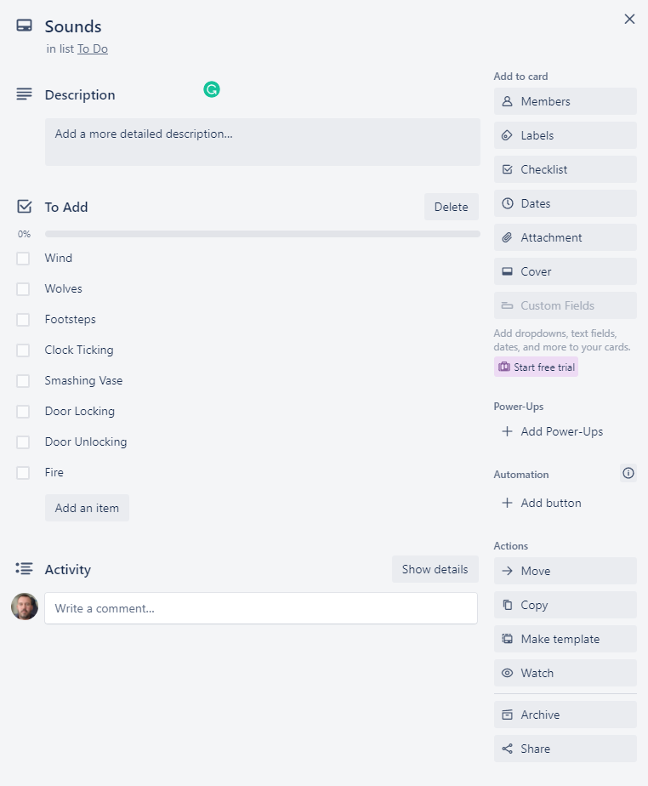

Figure 2.6 – Sounds card

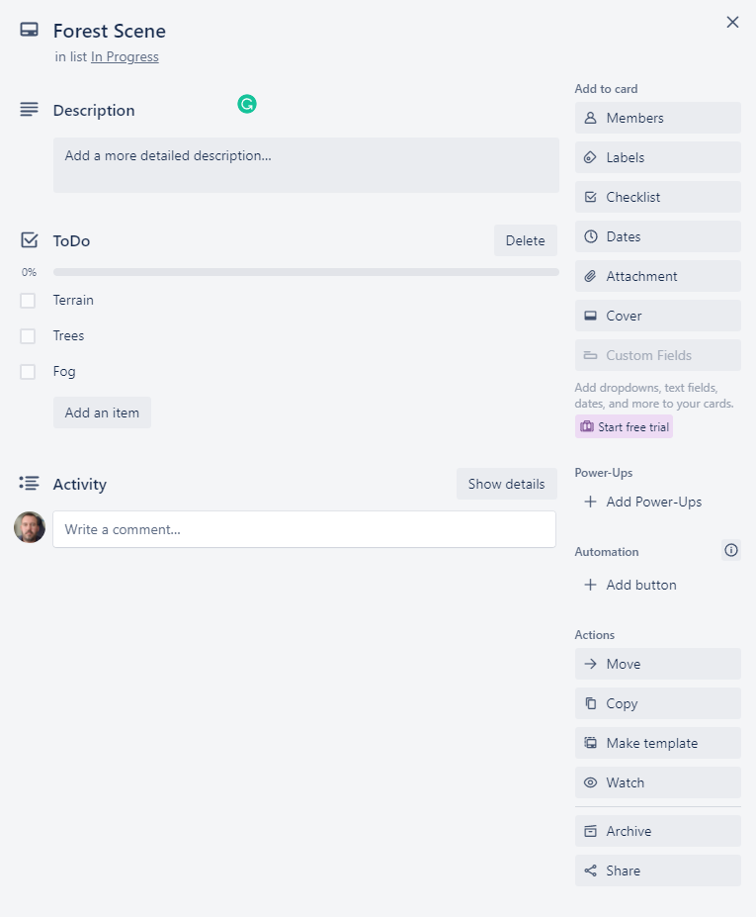

Figure 2.7 – Forest Scene card

## Week 1

The plan for week 1 is as follows

* Setup the Unity (Unity, 2021) project using the high definition render pipeline (HDRP).
* Create the main scene and add a Terrain.
* Paint textures on the terrain from the Forest Environment - Dynamic Nature (NatureManufacture_Forest_Environment, 2021) asset pack.
* Add Trees on the terrain using the Mountain Trees - Dynamic Nature (NatureManufacture_Mountain_Trees, 2021) asset pack.
* Implement the character's movement using the Starter Assets - First Person Character Controller (Unity_Starter_Assets, 2021) as a base to build upon.
* Start Modelling house using Blender (Blender, 2021)

The updated Trello (Atlassian, 2021) board at the end of week 1 is shown below (Figure 2.8) as well as the relevant expanded forest scene card (Figures 2.9) and the report card (Figure 2.10).

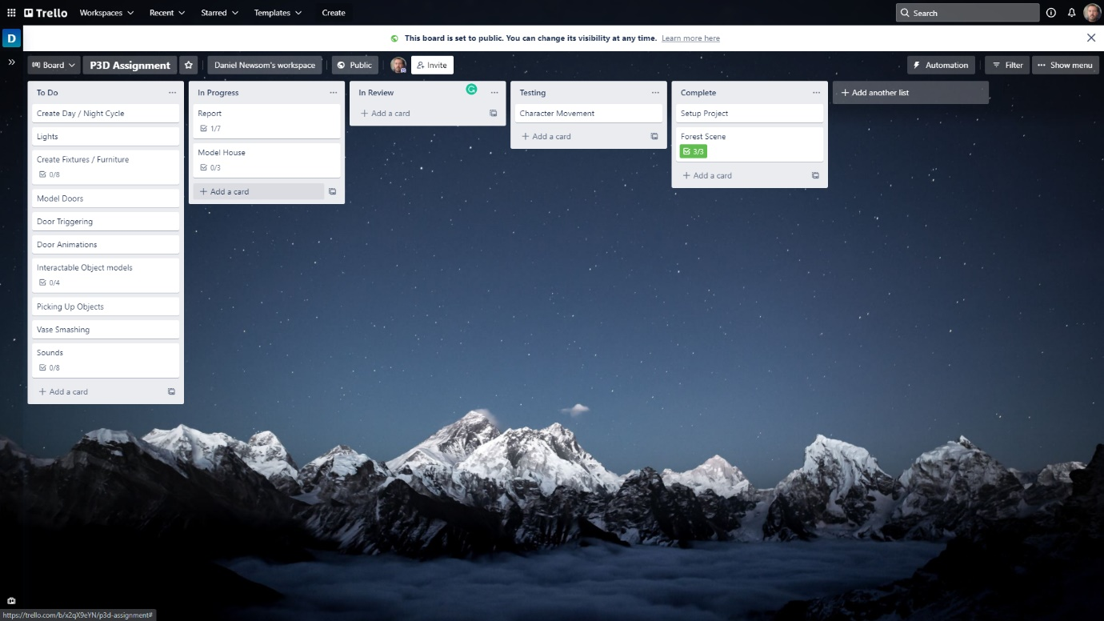

Figure 2.8 – Trello (Atlassian, 2021) board status at the end of week 1

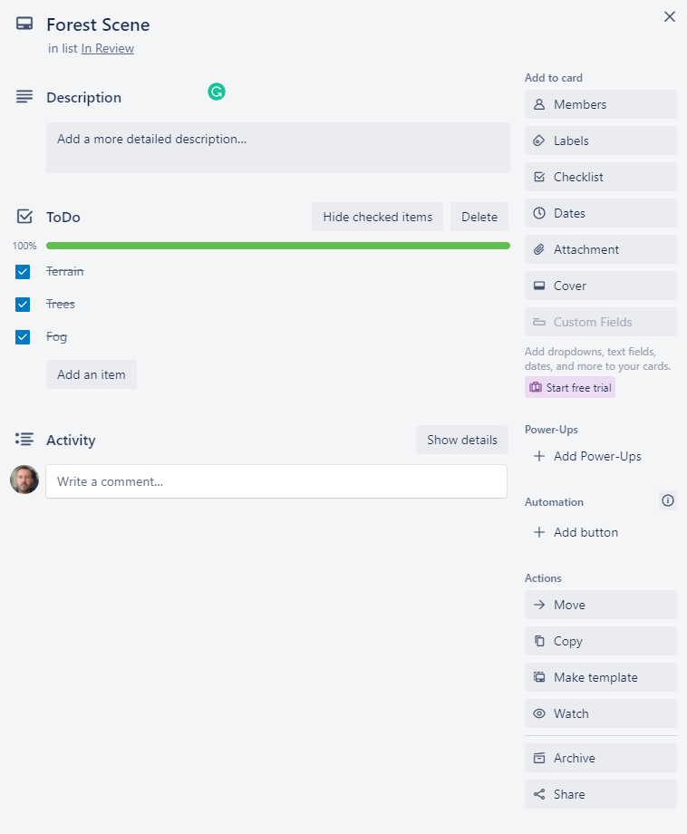

Figure 2.9 – Forest scene card updated

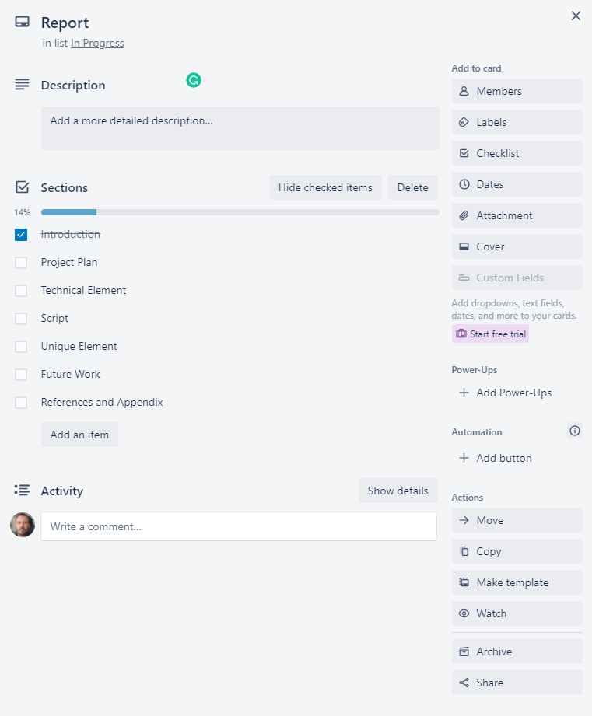

Figure 2.10 – Report card updated

## Week 2

The plan for week 2 is as below

* Finish modelling the house
* UV unwrap the house
* Add textures and materials to the house model
* Model the doors
* Animate the doors
* Add trigger scripts to the doors

The updated Trello (Atlassian, 2021) board at the end of week 2 is shown below (Figure 2.11) as well as the relevant expanded model house card (Figures 2.12)

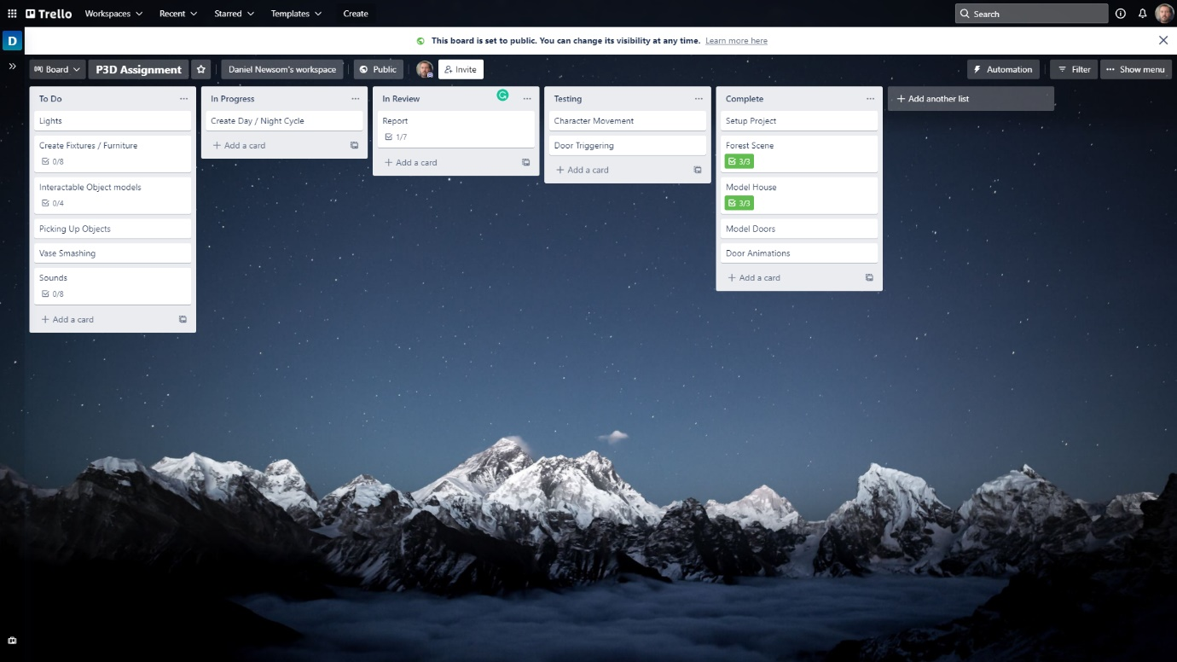

Figure 2.11 - Trello (Atlassian, 2021) board status at the end of week 2

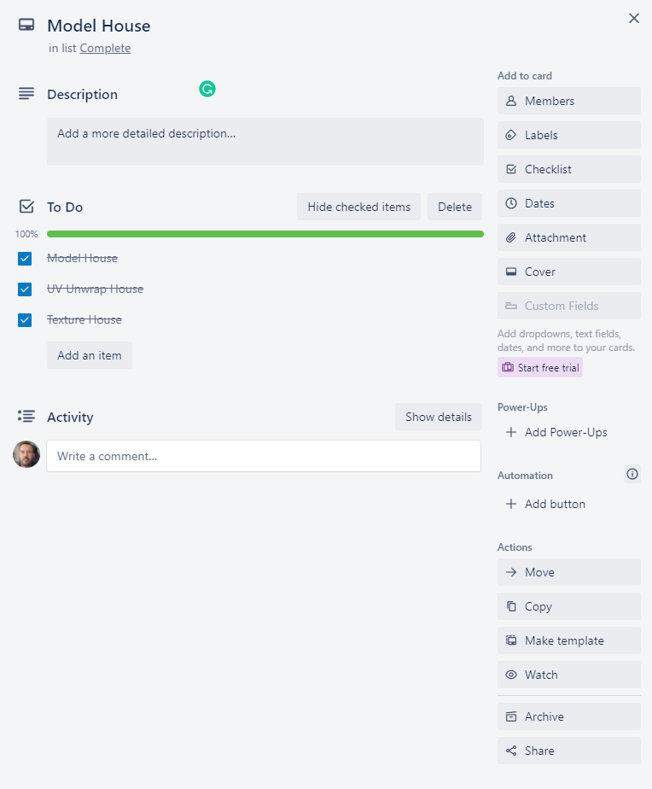

Figure 2.12 – Model House card expanded

## Week 3

The plan for week 3 is as follows

* Re-write the introduction section of the report
* Add chandelier model
* Animate chandelier model to sway
* Add light models to all other rooms
* Add/adjust lights to light models within Unity (Unity, 2021)
* Refactor Character controller script
* Start Day / Night Cycle animation and trigger.

The updated Trello (Atlassian, 2021) board at the end of week 3 is shown below (Figure 2.13) as well as the relevant expanded create fixtures/furniture card (Figures 2.14).

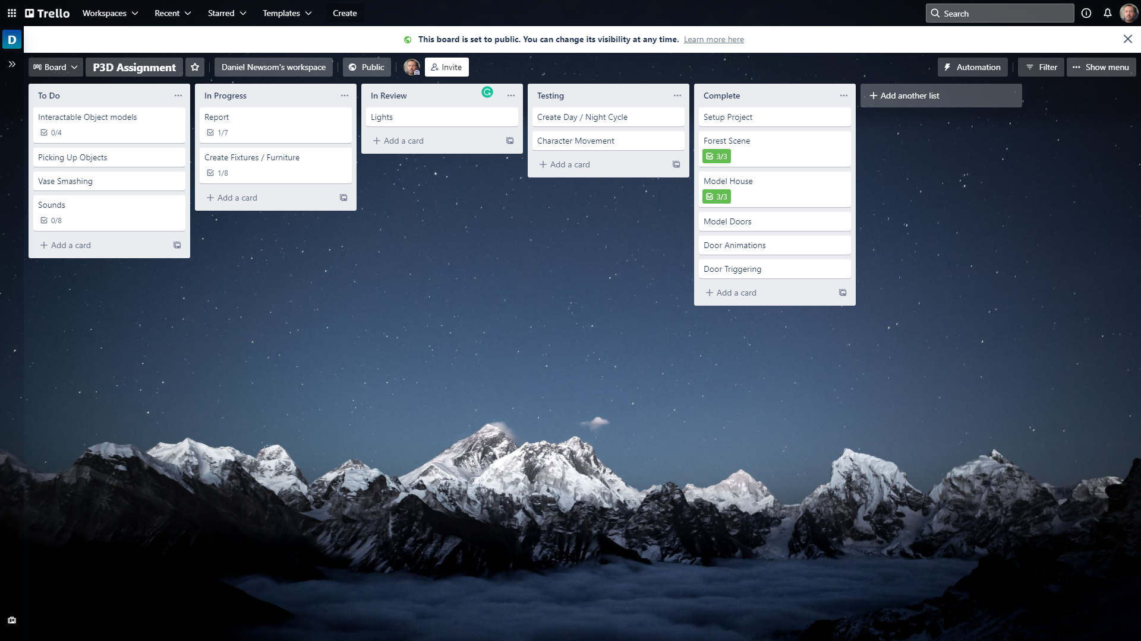

Figure 2.13 - Trello (Atlassian, 2021) board status at the end of week 3

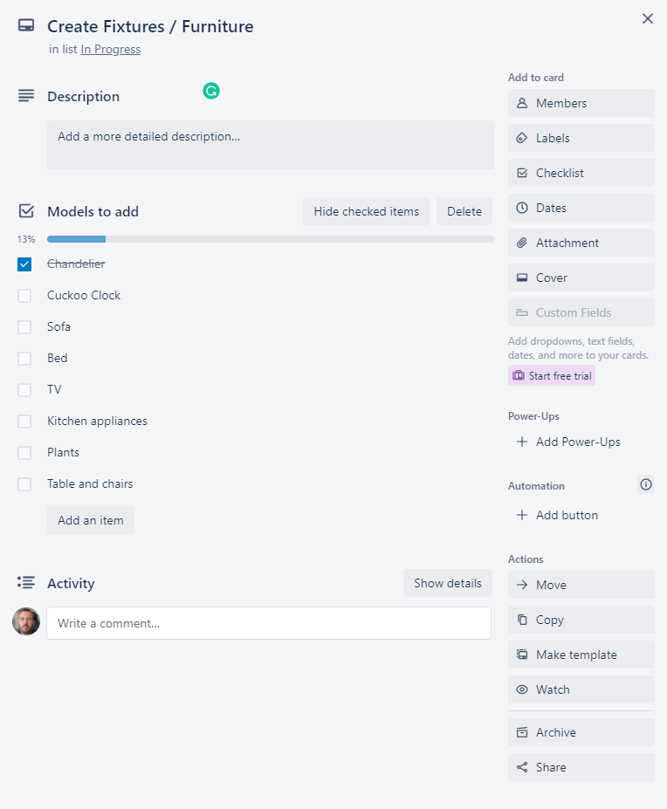

Figure 2.14 – Create Fixtures / Furniture card expanded

## Week 4

The plan for week 4 is as follows

* Model / add Interactable objects
* Start adding furniture (Priority Cuckoo clock)
* Implement picking up and using/throwing objects
* Add VFX fires and triggers
* Start adding sounds.

The updated Trello (Atlassian, 2021) board at the end of week 4 is shown below (Figure 2.15) as well as the relevant expanded Interactable Object models (figure 2.16), create fixtures/furniture card (figures 2.17) and Sounds card (figure 2.18).

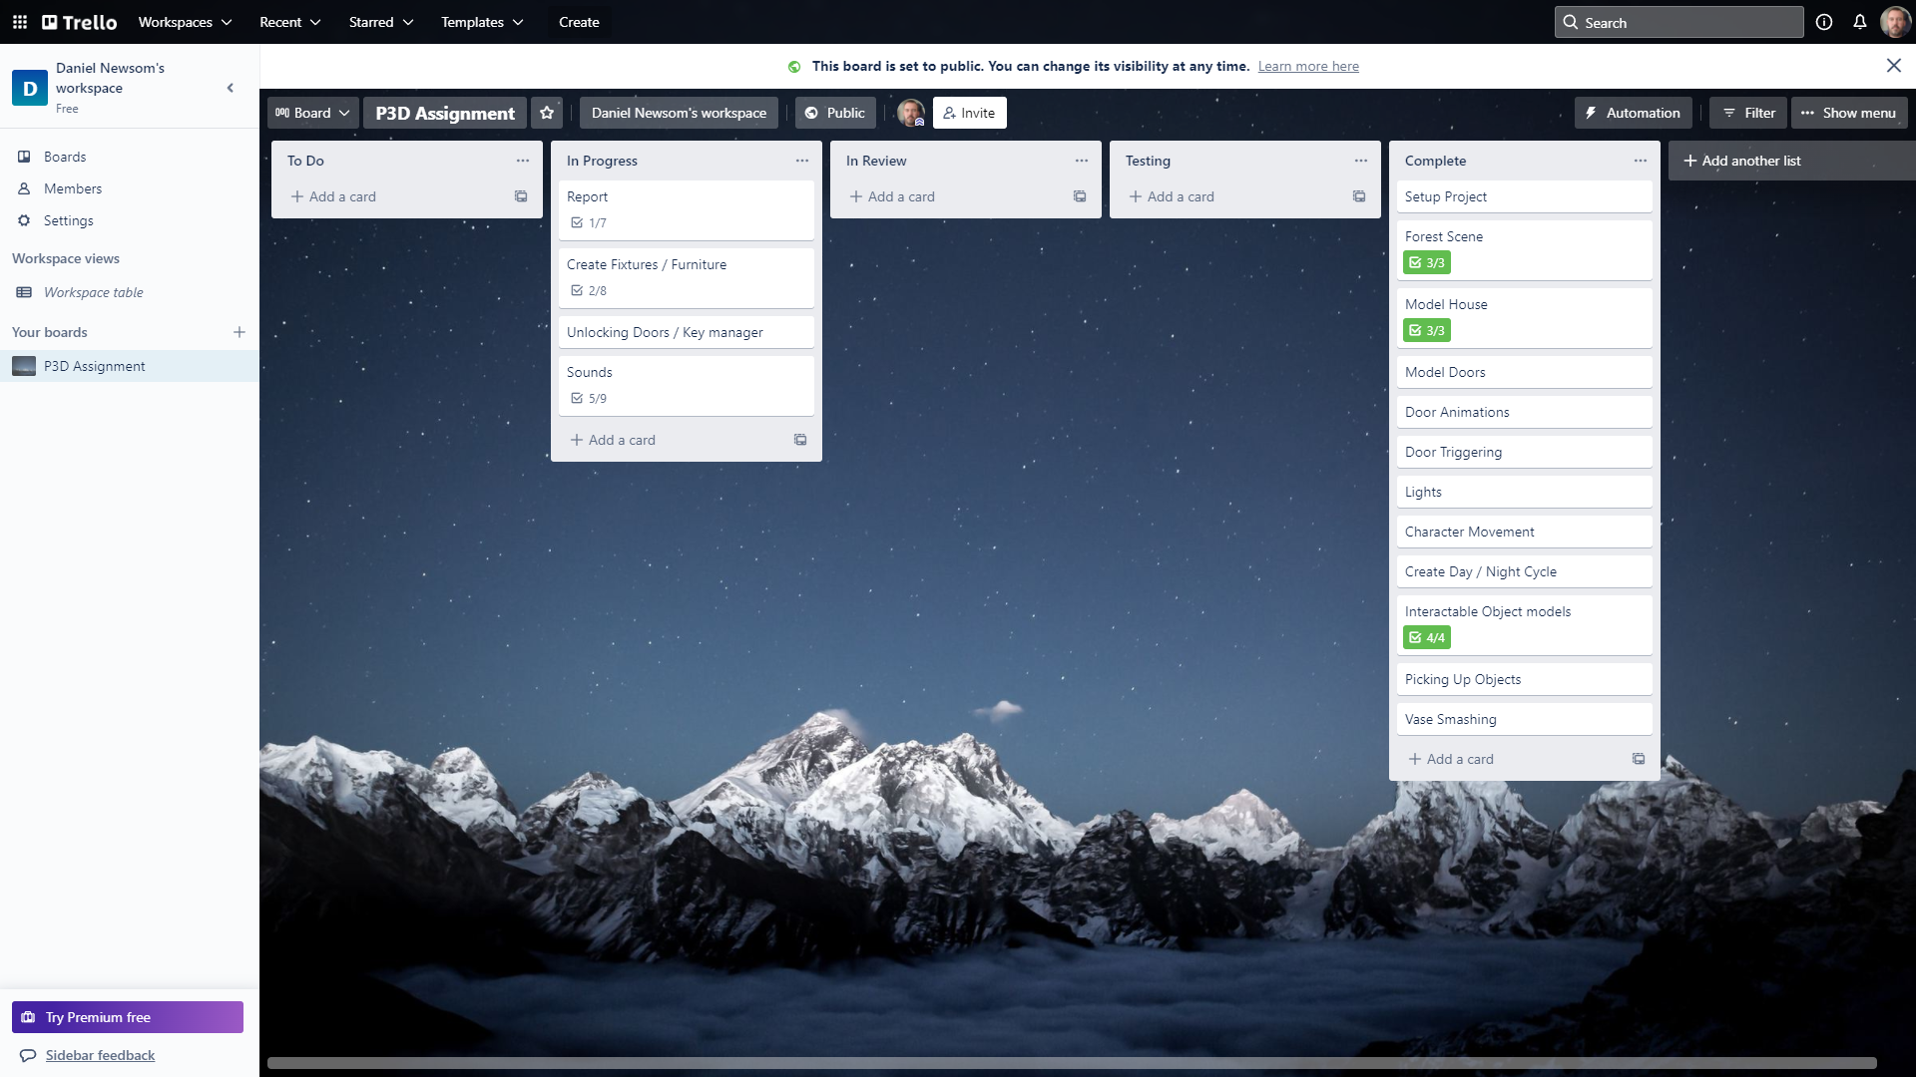

Figure 2.15 - Trello (Atlassian, 2021) board status at the end of week 4

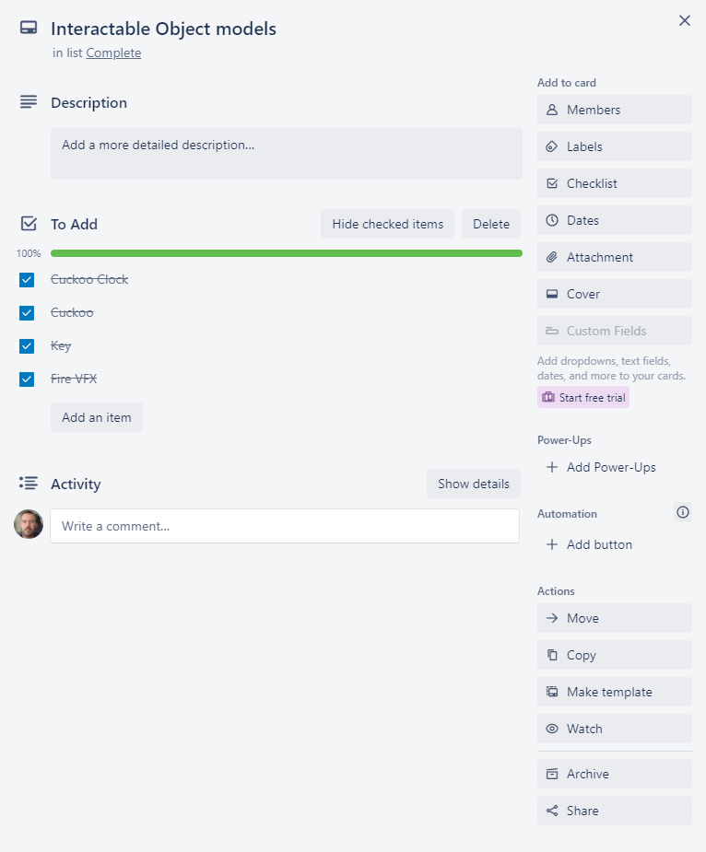

Figure 2.16 – Expanded Interactable object models card.

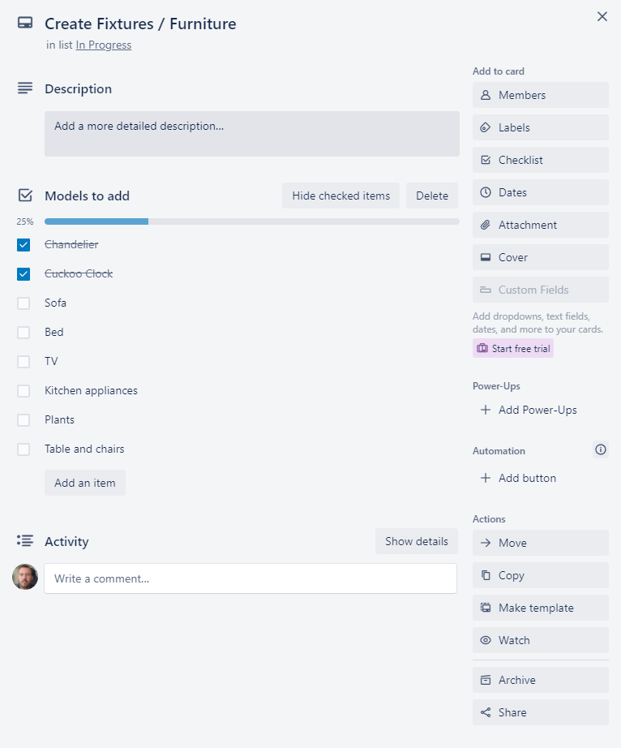

Figure 2.17 – Expanded Create Fixtures / Furniture card.

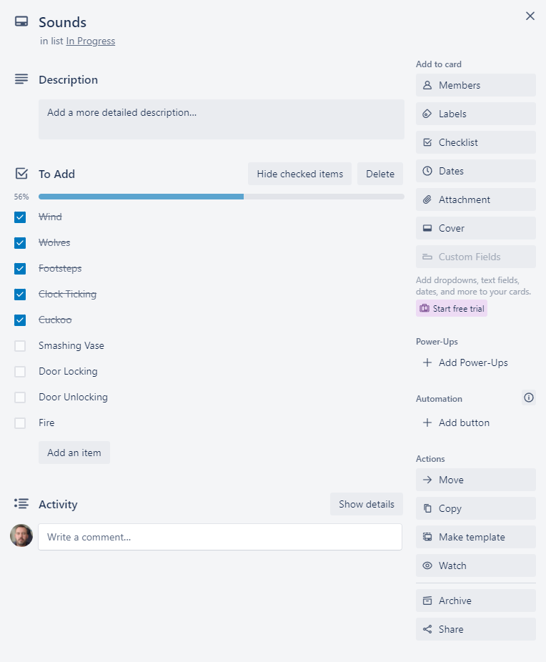

Figure 2.18 – Expanded Sounds card.

## Week 5

The plan for week 5 is as follows

* Implement collecting and using keys
* Add remaining fixtures and fittings
* Add remaining sounds
* Record first demo video for feedback

The updated Trello (Atlassian, 2021) board at the end of week 5 is shown below (Figure 2.19) as well as the relevant expanded Create fixtures/furniture card (figures 2.20) and Sounds card (figure 2.21).

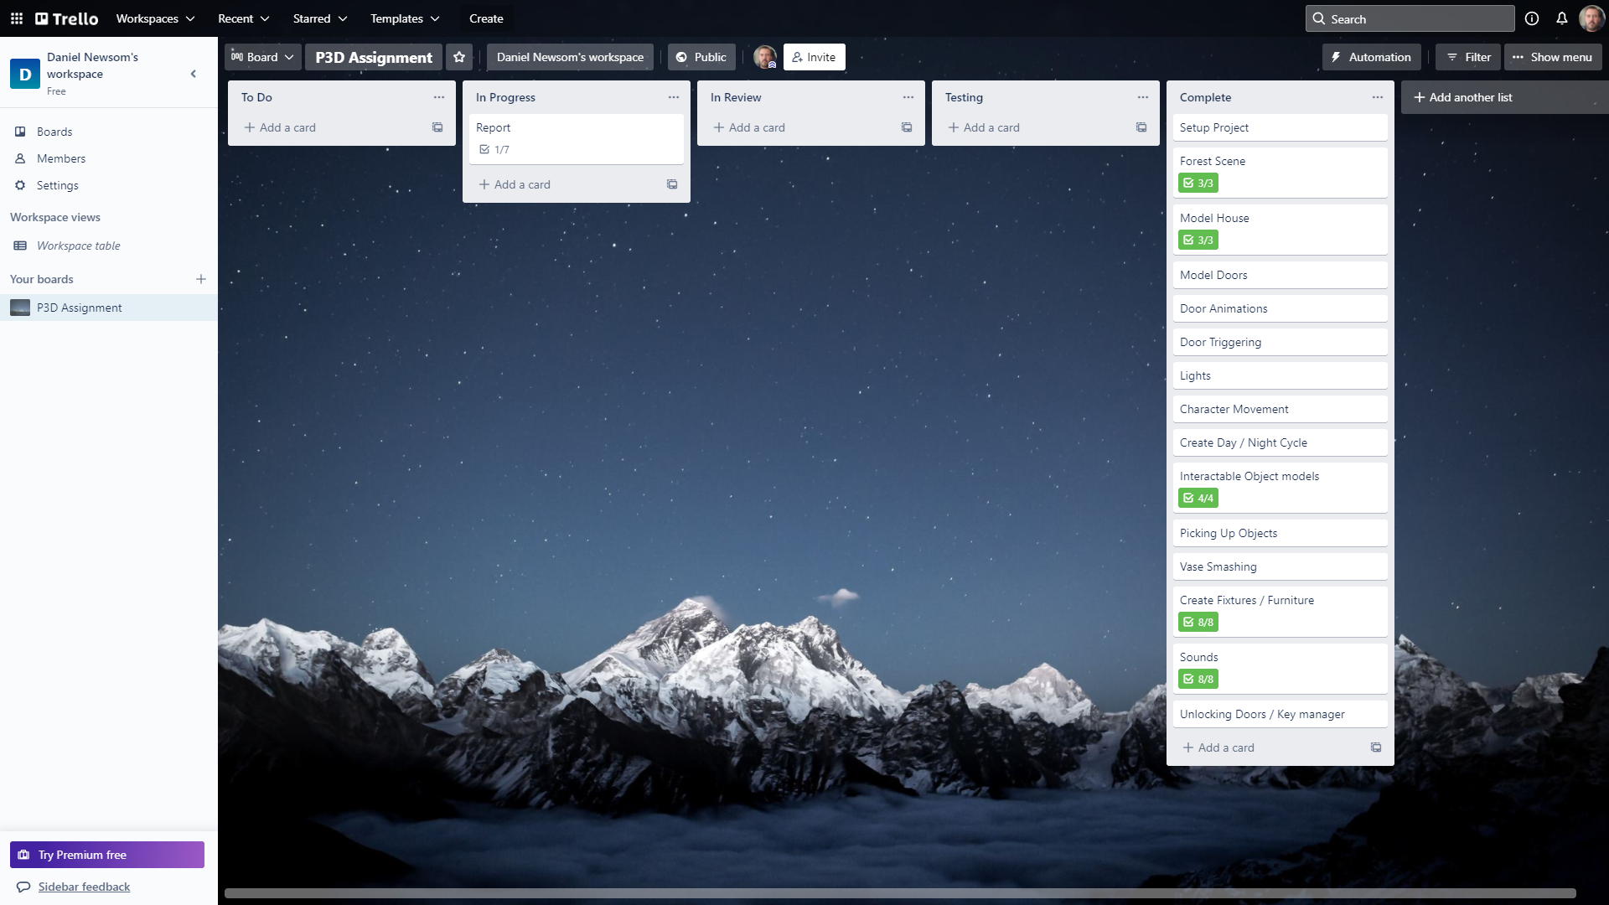

Figure 2.19 - Trello (Atlassian, 2021) board status at the end of week 5

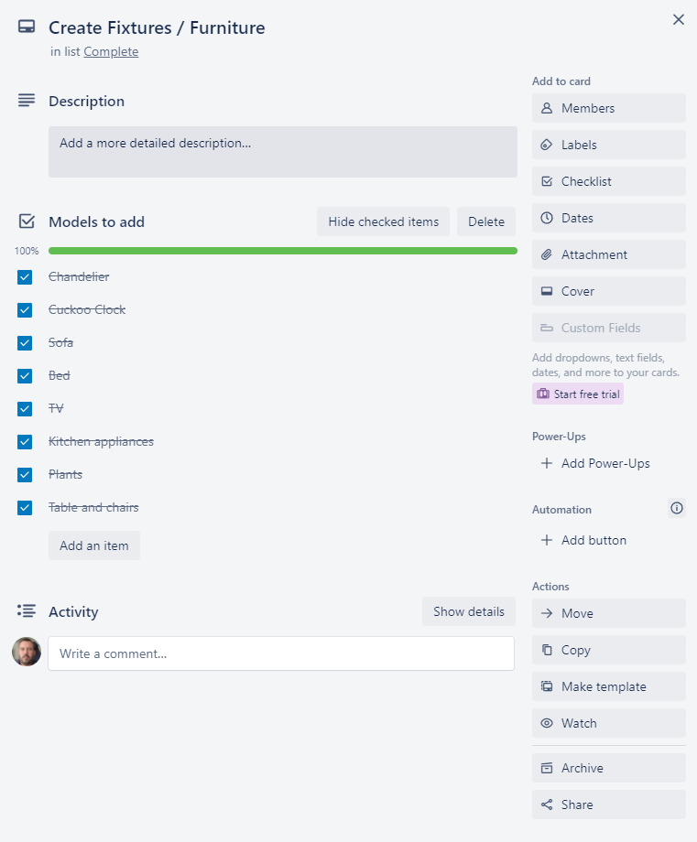

Figure 2.20 – Expanded Create Fixtures / Furniture card.

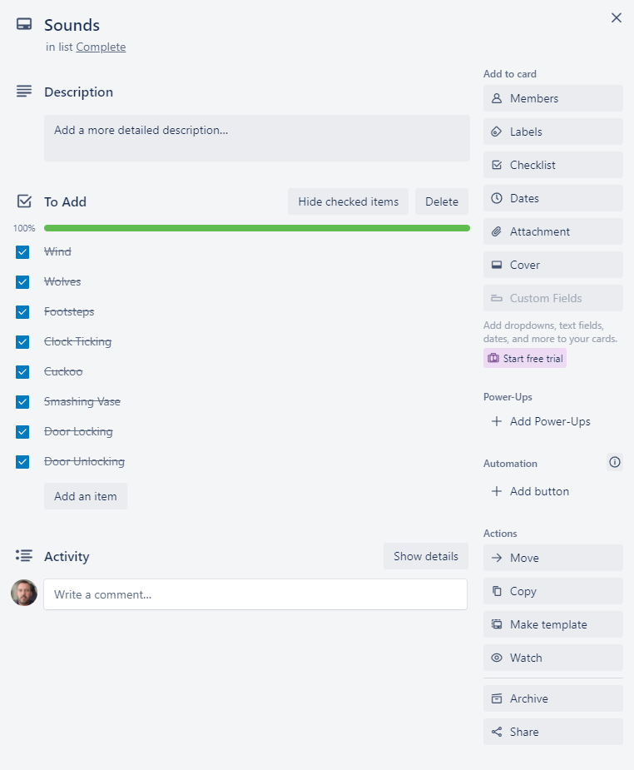

Figure 2.21 – Expanded Sounds card.

## Week 6

The plan for week 6 is as follows

* Add Asset references to the report
* Refactor and tidy up all scripts
* Add all scripts to the appendix
* Complete the remainder of the report

The updated Trello (Atlassian, 2021) board at the end of week 6 is shown below (Figure 2.22) as well as the relevant expanded Report Card (figures 2.23)

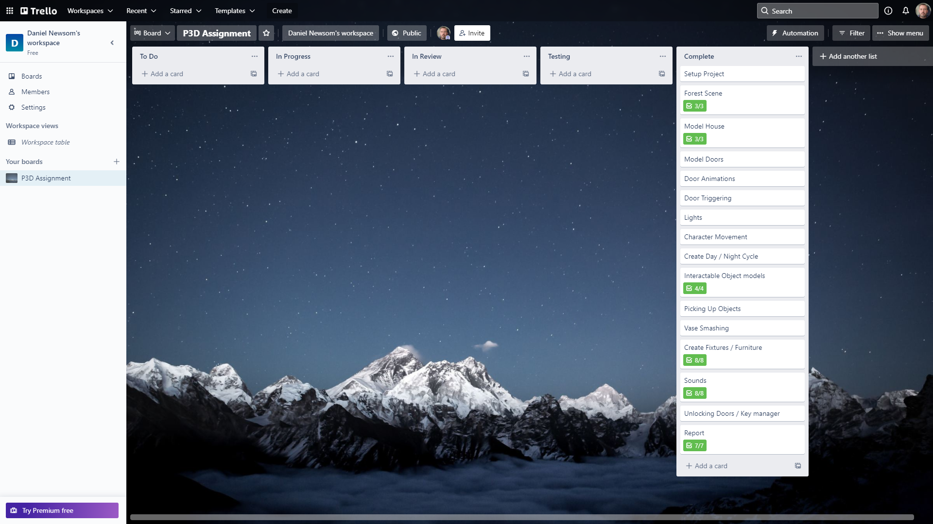

Figure 2.22 - Trello (Atlassian, 2021) board status at the end of week 6

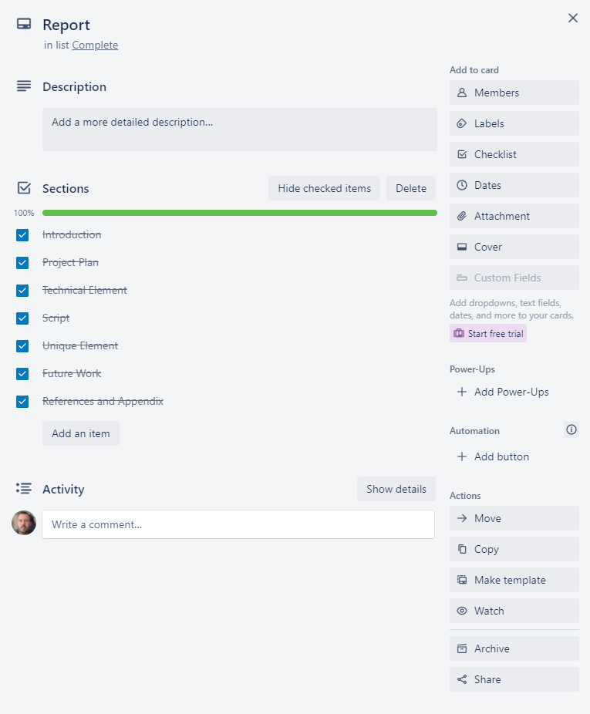

Figure 2.23 – Expanded Report Card

# Technical Element - Vectors

## Introduction

A vector is described by Marc Beaujean (Beaujean, 2020) as “a mathematical unit that can consist of more than one value.” He also states that “It's important to distinguish between vectors in traditional mathematics and in game engines”.

A vector in the context of game development is used to store an object’s various elements current state. They consist mainly of Vector3 with x,y and z values used for objects in 3D space or Vector2 with just the x and y value for objects in 2D space.

## Uses in Video Games

### Main uses

The main uses of Vectors are as follows.

* Store the position of an object, this is either relative to the scene as a whole (Global) or the object's parent as an offset (local).
* Store the rotation of an object around each of the vectors axes.
* Store an object’s current velocity and direction.

I used this in my project when detecting the vases collision with another object. If the objects current velocity in either the x,y or z axis was above the given threshold, then the SmashVase() method was called to destroy the object.

### Movement

Using vectors we can move an object by adding a movement vector to the objects current position to calculate the objects new position, as shown below (figure 3.1) in the diagram from R Nave (Nave, 2021)

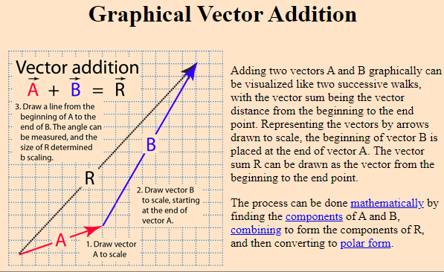

Figure 3.1 – Vector addition diagram (Nave, 2021)

We can move towards another object by getting the direction between them, by subtracting the target objects position from the current object’s position and normalizing this value to remove the distance. We can then add this value, multiplied by a distance value to the current object’s position vector to move towards that object by the given distance.

This is demonstrated in the code snippet below from Saad Khan (Khan, 2017)

// Calculate direction vector

Vector3 dir = obj1.transform.position - ob2.transform.position;  
// Normalize resultant vector to unit Vector  
dir = dir.normalized;  
// Move in the direction of the direction vector every frame   
obj1.transform.position += dir * Time.deltaTime * speed;

This process can be simplified by using the built-in MoveToward() function from the Vector classes.

### Distance

Vectors can be used to calculate distances between two objects using the Distance(Vector3, Vector3) method from the Vector Classes which returns the Euclidean distance between the two vectors.

The formula used for this calculation is as described by Rayman May (May, 2014)

Given two points in space $point a= \left(x_{0},y_{0},z_{0}\right), point b(x_{1},y_{1},z_{1})$

$distance=\sqrt{{(x_{1}-x_{0})}^{2}+{(y_{1}-y_{0})}^{2}+{(z_{1}-z_{0})}^{2}}$

### Other Uses

Vectors within Unity can also be used to store various other variables requiring multiple values for example a range between two floats by storing the min and max values in the x and y values respectively.

I used a Vector2 in my Lightbulb script to set a min and max wait time for the bulb to wait before flickering off and on again.

[SerializeField] private Vector2 flickerDelay = new Vector2(0.1f, 5f);

I then selected a random value between these to use as the countdown until the next flicker

private void **FixedUpdate**()  
{  
 if (flickering)  
 {  
 _flickerDelayTimer -= Time.deltaTime;  
 if (_flickerDelayTimer <= 0)  
 {  
 SwitchLightsOff();  
 _flickerDelayTimer = Random.Range(flickerDelay.x, flickerDelay.y);  
 Invoke(nameof(SwitchLightsOn),Random.Range(flickerOffTime.x,flickerOffTime.y));  
 }  
 }  
}

# Script – ItemGrabber.cs

The script I have chosen to highlight is the ItemGrabber.cs (Appendix 9.1.12.) which is used to pick up objects and keys, throw held objects as well as update the UI when the player is looking at an interactable item.

The beginning of the script is used in the usual way by declaring system packages, variables, and a start method to set any required private member variables.

using System.Collections.Generic;  
using UnityEngine;  
  
public class **ItemGrabber** : MonoBehaviour  
{  
 [SerializeField] private LayerMask **pickupLayerMask**;  
 [SerializeField] private float **raycastDistance** = 5f;  
 [SerializeField] private Transform **cameraTransform**;  
 [SerializeField] [Range(0f,20f)] private float **throwForce** = 10f;  
  
 private readonly List<GameObject> _heldItems = new List<GameObject>();  
 private KeyManager _keyManager;  
 private PlayerInputHandler _playerInputHandler;  
 private UIController _uiController;  
 private GameObject _currentItem;  
 private int _currentItemIndex;  
 private bool _inCooldown;  
  
 private void **Start**()  
 {  
 _playerInputHandler = FindObjectOfType<PlayerInputHandler>();  
 _keyManager = FindObjectOfType<KeyManager>();  
 _uiController = FindObjectOfType<UIController>();  
 }

This is followed by the Update method which first performs a Raycast forward from the centre of the camera using a layer mask. This contains an out Raycast hit variable used in the remainder of the method. If this Raycast is successful, then the player is looking at an interactable object and the UI Controller is called to update the display to which interactable item is being looked at by the player.

private void **Update**()  
{  
 if (Physics.Raycast(cameraTransform.position, cameraTransform.forward, out RaycastHit hitInfo,  
 raycastDistance,  
 pickupLayerMask, QueryTriggerInteraction.Collide))  
 {  
 if (hitInfo.transform.TryGetComponent<Key>(out Key key))  
 {  
 _uiController.SetInfoDisplay($"Pick up {KeyManager.GetKeyName(key.DoorToOpen)} key");  
 }  
 else if (hitInfo.transform.TryGetComponent<Pickup>(out Pickup pickup))  
 {  
 _uiController.SetInfoDisplay($"Pick up {pickup.Type}");  
 }  
 }  
 else  
 {  
 _uiController.SetInfoDisplay("");  
 }

The script then returns if the in cooldown boolean variable is true. This stops multiple keypresses from being detected in each update cycle.

if(_inCooldown){return;}

If the script is not in a cooldown, it then checks if the pickup/throw button has been pressed on the Player Input Handler this cycle and then checks if the hit info variable is valid (i.e not null).

if (_playerInputHandler.Throw)  
{  
 if (hitInfo.transform)  
 {

If the hit info is valid, then the player is either looking at a key or a pickup item and so the script first checks if the hit info object has a key script and if it does, collects the key and adds it to the Key Manager. The script then sets the cooldown boolean to true and invokes a method with a delay to reset the cooldown boolean and returns.

if (hitInfo.transform.CompareTag("Key"))  
{  
 if (hitInfo.transform.TryGetComponent<Key>(out Key key))  
 {  
 _keyManager.AddKey(key.DoorToOpen);  
 Destroy(hitInfo.transform.gameObject);  
 }  
 _inCooldown = true;  
 Invoke(nameof(ResetCooldown),0.2f);  
 return;  
}

If the hit info object is not a pickup or the player already has that object, then the method returns.

if (!hitInfo.transform.CompareTag("Pickup") ||

_heldItems.Contains(hitInfo.transform.gameObject)) return;

If the hit info object is a pickup, then the script adds it to the held items list, sets it as the current item, sets its index in the held Items List as the current item index and sets the object to active using the SetActiveObject() method (see below). This enables cycling through multiple held objects.

_currentItem = hitInfo.transform.gameObject;  
_heldItems.Add(_currentItem);  
_currentItemIndex = _heldItems.IndexOf(_currentItem);  
SetActiveObject();

The script then disables this new current item object RigidBody and Collider so that it does not interfere with the player's movement and then sets its parent, position, and rotation to the item grabbers transform. Finally, the scale of the object is set to 0.25 on all axes and as before the cooldown is initiated.

_currentItem.GetComponent<Rigidbody>().isKinematic = true;  
_currentItem.GetComponent<Collider>().enabled = false;  
Transform grabberTransform = transform;  
_currentItem.transform.parent = grabberTransform;  
_currentItem.transform.position = grabberTransform.position;  
_currentItem.transform.rotation = grabberTransform.rotation;  
_currentItem.transform.localScale = new Vector3(0.25f,0.25f,0.25f);  
_inCooldown = true;  
Invoke(nameof(ResetCooldown),0.2f);

If the player is not looking at an interactable object (but has pressed the pickup/throw key), then it is assumed that the player wants to throw the current object.

The script first checks that there is a valid current item and returns if not.

if (!_currentItem) return;

if the current item is valid then it is removed from the held items list and stored in a temporary variable.

GameObject itemToThrow = _currentItem;  
_heldItems.Remove(itemToThrow);

If the player has other items in the held items list, then the item at the end of the list is set as the current item as previously. The current item is set to null if the list length is 0.

if (_heldItems.Count > 0)  
{  
 _currentItem = _heldItems[_heldItems.Count - 1];  
 _currentItemIndex = _heldItems.IndexOf(_currentItem);  
 SetActiveObject();  
}  
else  
{  
 _currentItem = null;  
}

The temporary item to throw variable then has its parent removed, it Rigidbody and Collider re-enabled and scale reset to 1. It also has a force applied to its Rigidbody to propel it forward using the throw force variable. Again, the cooldown process is then triggered.

itemToThrow.transform.parent = null;  
 itemToThrow.GetComponent<Collider>().enabled = true;  
 itemToThrow.TryGetComponent<Rigidbody>(out Rigidbody itemRb);  
 itemRb.isKinematic = false;  
 itemRb.AddForce(cameraTransform.forward * (throwForce * 100f), ForceMode.Acceleration);  
 itemToThrow.transform.localScale = new Vector3(1, 1, 1);  
 _inCooldown = true;  
 Invoke(nameof(ResetCooldown),0.2f);  
 }  
}

If the Pickup/throw button was not pressed this cycle, then finally the script checks both the next and previous item buttons on the Player input and calls each one’s corresponding method if it has been pressed this cycle.

else  
{  
 if (_playerInputHandler.NextItem)  
 {  
 NextItem();  
 }  
 else if (_playerInputHandler.PreviousItem)  
 {  
 PreviousItem();  
 }  
}

The NextItem() method is used to cycle to the next item held by the player.

It first gets the number of items held and returns if it is 1 or less.

private void NextItem()  
{  
 int numberOfItems = _heldItems.Count;  
 if(numberOfItems <= 1){return;}

If not then if the current item index is the last item in the list, it is set to the first. If it is not the last item then it is simply incremented.

if (_currentItemIndex == numberOfItems-1)  
{  
 _currentItemIndex = 0;  
}  
else  
{  
 _currentItemIndex++;  
}

The current item is then set to the item in the held items list that corresponds to this new index and is set as the active object using the SetActiveObject()method (see below).

_currentItem = _heldItems[_currentItemIndex];  
SetActiveObject();

The cooldown process is then called as before.

_inCooldown = true;  
 Invoke(nameof(ResetCooldown),0.2f);  
}

The PreviousItem() method is identical to the NextItem() method except that if the item is the first item in the held items list it is set to the last, and if not it is simply decremented.

private void PreviousItem()  
{  
 int numberOfItems = _heldItems.Count;  
 if(numberOfItems <= 1){return;}  
  
 if (_currentItemIndex == 0)  
 {  
 _currentItemIndex = numberOfItems - 1;  
 }  
 else  
 {  
 _currentItemIndex--;  
 }  
 _currentItem = _heldItems[_currentItemIndex];  
 SetActiveObject();  
 _inCooldown = true;  
 Invoke(nameof(ResetCooldown),0.2f);  
}

The SetActiveObject() method returns if there are no items in the held items list.

If there are items held then it will cycle through each, in turn, using a for loop and set the object to active if the current item index equals the current for loop index or set inactive if it does not.

private void SetActiveObject()  
{  
 if (_heldItems.Count <= 0) return;  
  
 for (int i = 0; i < _heldItems.Count; i++)  
 {  
 if (i == _currentItemIndex)  
 {  
 _heldItems[i].SetActive(true);  
 }  
 else  
 {  
 _heldItems[i].SetActive(false);  
 }  
 }  
}

The ResetCooldown method simply sets the in cooldown boolean to false and is called using the Invoke(string methodName, float time) method to add a delay to the call.

private void ResetCooldown()  
{  
 _inCooldown = false;  
}

# Unique Element – Day / Night Cycle

I used the Unity (Unity, 2021) HDRP for my project and as such created a Physically based sky for the scene. I added two versions of this for both Daytime and Night-time and then animated the sun and moon objects to rotate across the sky.

This process also allowed me to add animation events to switch out the volume profiles to adjust each one’s fog and post-processing separately as well as change the ambient sounds for each one and switch on and off the house lights.

I also used this animation to animate the hands of the cuckoo clock to match the time of day or night within the scene.

The scene starts by looping perpetually through the night-time animation until the player escapes the house, the animation is then fast-forwarded to the daytime animation using triggers on the animator object.

# Summary

The scene that I created consisted of a forest area containing a spooky house, stuck in a perpetual night-time cycle. The player must then enter the house, complete the tasks highlighted within the introduction section picking up and using objects and keys to unlock the conservatory door and escape. This then triggers the daytime cycle and displays a “You escaped message to the player.

The player controller used was an edited version of the Starter Assets - First Person Character Controller (Unity_Starter_Assets, 2021)

The exterior of the scene was put together using terrain textures from Forest Environment - Dynamic Nature (NatureManufacture_Forest_Environment, 2021) and trees from Mountain Trees - Dynamic Nature (NatureManufacture_Mountain_Trees, 2021)

The House and many of the fixtures and fittings were modelled, UV unwrapped and textured by me. Some of the furniture was re-used from a previous Clue (Newsom (Clue), 2021) coursework project that were initially all modelled by me. Others were used from various other sources including my portfolio website (Newsom, 2021) as detailed in section 8.2 Assets.

# Future Work

I believe that there is scope for various other puzzles and objects within the house to prolong the playtime and make the whole process trickier. These could include

* Playing a set of notes on the piano.
* Switching the channel on the TV to show some hidden item via a security camera.
* Get something from the fridge and put it in the oven.
* Adding a secret room behind one of the bookcases.
* Potting a ball on the pool table to eject a key or item.
* Watering a plant in the house to produce an item.
* I could also add a timer and high scores to try and beat the time to escape the house.

# References

## Github

Main Github page - <https://github.com/dgnewsom>

Project Repository - <https://github.com/dgnewsom/215851_P3D>

## Assets

### Models

* **Apple Model** - (Baria3DAsset(Apple), 2020)
* **Banana Model** - (Baria3DAsset(Banana), 2020)
* **Bath** - (diger-mpt, 2019)
* **Bath Tap** - (Renderscope, 2015)
* **Bookcases** - (Newsom (Clue), 2021)
* **Desk** - (Newsom (Clue), 2021)
* **Dining Set**
  + **Table** - (Newsom (Clue), 2021)
  + **Chair** - (Newsom (Chair), 2021)
* **Fridge** - (Newsom (Clue), 2021)
* **Hat Stand**
  + **Gangster Hat** - (MichalCavrnoch, 2020)
  + **Cowboy Hat** - (vanmourik-elise, 2016)
* **Kitchen Cupboards** - (Newsom (Clue), 2021)
* **Orange Model** - (mikailtasim, 2019)
* **Oven** - (Newsom (Clue), 2021)
* **Piano** - (choughry, 2021)
* **Plant** - (dominiklesniak, 2018)
* **Pool Table** - (Newsom (Pool Table), 2021)
* **Shower** - (claudiodubas, 2015)
* **Shower Cubicle** - (sweethome3d, 2013)
* **Sink** - (BSW2142, 2018)
* **Sofa** - (Newsom (Sofa), 2021)
* **Telephone Table** 
  + **Table** - (Newsom (Clue), 2021)
  + **Old Phone** - (Polymake, 2020)
  + **NoteBook** - (Hard, 2021)
* **Television and Stand** - (Newsom (Clue), 2021)
* **Toilet Model** - (MarkStead, 2021)
* **Toilet Roll Models** - (dandcowan, 2021)

### Audio

* **Bird Song** - (Imjeax, 2018)
* **Clock Tick** - (straget, 2019)
* **Cuckoo** - (InspectorJ, 2017)
* **Door Close** - (rivernile7, 2014)
* **Door Lock / Unlock** - (Fabrizio84, 2019)
* **Door Open** - (pagancow, 2006)
* **Footstep Sounds** - (Glowkeeper_(Footsteps_Audio), 2021)
* **Piano** - (deadrobotmusic, 2021)
* **Serving Hatch** - (craigsmith, 2018)
* **Vase Smash** - (kingsrow, 2013)
* **Wind** - (nsstudios, 2019)
* **Wolf Sounds** 
  1. (y89312, 2011)
  2. (killyourpepe, 2017)
  3. (cazadordoblekatana, 2018)
  4. (newagesoup, 2016)
  5. (NaturesTemper, 2017)

### Fonts

* **Title Font** - (PutraCetol, 2021)
* **UI Font** - (Art_Power, 2017)

### Sprites

* **Smoke Sprite Sheet** - (Beast, 2013)

### Scripts

* **Character Controller** - (Unity_Starter_Assets, 2021)
* **Footsteps code** - (Glowkeeper_(Footsteps_Code), 2021)

### Full References

Art_Power, 2017. *DaFont - Stranger back in the Night.* [Online]   
Available at: https://www.dafont.com/stranger-back-in-the-night.font  
[Accessed 9 December 2021].

Atlassian, 2021. *Trello.* [Online]   
Available at: https://trello.com/  
[Accessed 5 November 2021].

Baria3DAsset(Apple), 2020. *CGTrader - Apple Fruit Free low-poly 3D model.* [Online]   
Available at: https://www.cgtrader.com/free-3d-models/food/fruit/apple-fruit-afa5e664-8ff8-4598-9568-a21c35520ca3  
[Accessed 7 December 2021].

Baria3DAsset(Banana), 2020. *CGTrader - Banana Free low-poly 3D model.* [Online]   
Available at: https://www.cgtrader.com/free-3d-models/food/fruit/banana-a86fda85-aa6c-4261-8d87-da597aa55f28  
[Accessed 7 December 2021].

Beast, 2013. *OpenGameArt.Org - Swirling Prerendered Smoke Animation with seamless looping..* [Online]   
Available at: https://opengameart.org/content/smoke-aura  
[Accessed 3 December 2021].

Beaujean, M., 2020. *Vector Maths for Game Dev Beginners.* [Online]   
Available at: https://www.gamedeveloper.com/disciplines/vector-maths-for-game-dev-beginners  
[Accessed 10 December 2021].

Blender, 2021. *Blender.* [Online]   
Available at: https://www.blender.org/  
[Accessed 5 November 2021].

BSW2142, 2018. *CGTrader - Marble Bathroom Sink Free low-poly 3D model.* [Online]   
Available at: https://www.cgtrader.com/free-3d-models/furniture/other/bathroom-sink-07b46f36-c6ba-41d5-ad60-9475c96988fc  
[Accessed 8 December 2021].

cazadordoblekatana, 2018. *Freesound - 15-WolfCrying.wav.* [Online]   
Available at: https://freesound.org/people/cazadordoblekatana/sounds/429109/  
[Accessed 29 November 2021].

choughry, 2021. *CGTrader - Piano Free 3D model.* [Online]   
Available at: https://www.cgtrader.com/free-3d-models/interior/house/piano-7956bf16-98c3-4bd3-8171-8df382638c08  
[Accessed March 2021].

claudiodubas, 2015. *CGTrader - Shower 4 Free 3D model.* [Online]   
Available at: https://www.cgtrader.com/free-3d-models/interior/bathroom/shower-4--2  
[Accessed 8 December 2021].

craigsmith, 2018. *Freesound - G31-04-Small Wooden Door.wav.* [Online]   
Available at: https://freesound.org/people/craigsmith/sounds/438442/  
[Accessed 9 December 2021].

dandcowan, 2021. *CGTrader - Toilet Rolls Free 3D model.* [Online]   
Available at: https://www.cgtrader.com/free-3d-models/household/other/toilet-rolls  
[Accessed 8 December 2021].

deadrobotmusic, 2021. *Freesound - SOS Dark Piano Loop [148bpm] [C Minor].* [Online]   
Available at: https://freesound.org/people/deadrobotmusic/sounds/574346/  
[Accessed 8 December 2021].

diger-mpt, 2019. *CGTrader - Asymmetric bathtub size 1600x1100 Free 3D model.* [Online]   
Available at: https://www.cgtrader.com/free-3d-models/interior/bathroom/asymmetric-bathtub-size-1600x1100  
[Accessed 8 December 2021].

dominiklesniak, 2018. *CGTrader - monstera-deliciosa.* [Online]   
Available at: https://www.cgtrader.com/free-3d-models/plant/pot-plant/monstera-deliciosa  
[Accessed March 2021].

Fabrizio84, 2019. *Freesound - Locking Door.* [Online]   
Available at: https://freesound.org/people/Fabrizio84/sounds/458013/  
[Accessed 6 December 2021].

Glowkeeper_(Footsteps_Audio), 2021. *Github - P3D/assets/audio/.* [Online]   
Available at: https://github.com/glowkeeper/P3D/tree/master/assets/audio  
[Accessed 29 November 2021].

Glowkeeper_(Footsteps_Code), 2021. *Github - P3D Lab for Week 4, Session 2 - Audio in Unity.* [Online]   
Available at: https://github.com/glowkeeper/P3D/blob/master/docs/labs/week4Session2.md  
[Accessed 29 November 2021].

Hard, A., 2021. *CGTrader - A4 Notebook 3d model nots student mockup school Free low-poly 3D model.* [Online]   
Available at: https://www.cgtrader.com/free-3d-models/household/other/a4-notebook-3d-model-nots-student-mockup-school  
[Accessed March 2021].

Imjeax, 2018. *Freesound - Forest Ambient LOOP.* [Online]   
Available at: https://freesound.org/people/Imjeax/sounds/427400/  
[Accessed 29 November 2021].

InspectorJ, 2017. *Freesound - Cuckoo Clock, Single, A.wav.* [Online]   
Available at: https://freesound.org/people/InspectorJ/sounds/398194/  
[Accessed 29 November 2021].

Khan, S., 2017. *Unity - moving one gameobject towards another.* [Online]   
Available at: https://answers.unity.com/questions/1303472/moving-one-gameobject-towards-another.html  
[Accessed 10 December 2021].

killyourpepe, 2017. *Freesound - DuskWolf.wav.* [Online]   
Available at: 1. https://freesound.org/people/killyourpepe/sounds/395192/  
[Accessed 29 November 2021].

kingsrow, 2013. *Freesound - BreakingVase02.wav.* [Online]   
Available at: https://freesound.org/people/kingsrow/sounds/194684/  
[Accessed 9 December 2021].

MarkStead, 2021. *CGTrader - Toilet Suite Kohler Reach 5233A-0 Free 3D model.* [Online]   
Available at: https://www.cgtrader.com/free-3d-models/interior/bathroom/toilet-suite-kohler-reach-5233a-0  
[Accessed 8 December 2021].

May, R., 2014. *Calculate distance in 3D space.* [Online]   
Available at: https://math.stackexchange.com/q/1069627  
[Accessed 10 December 10].

MichalCavrnoch, 2020. *CGTrader - Gangster hats Free 3D model.* [Online]   
Available at: https://www.cgtrader.com/free-3d-models/character/clothing/gangster-hats  
[Accessed March 2021].

mikailtasim, 2019. *CGTrader - Orange Free 3D model.* [Online]   
Available at: https://www.cgtrader.com/free-3d-models/food/fruit/orange-f548261d-6a73-4f1f-a318-0236d1c2b22b  
[Accessed 7 December 2021].

NatureManufacture_Forest_Environment, 2021. *Forest Environment - Dynamic Nature.* [Online]   
Available at: https://assetstore.unity.com/packages/3d/vegetation/forest-environment-dynamic-nature-150668  
[Accessed 5 November 2021].

NatureManufacture_Mountain_Trees, 2021. *Mountain Trees - Dynamic Nature.* [Online]   
Available at: https://assetstore.unity.com/packages/3d/vegetation/trees/mountain-trees-dynamic-nature-107004  
[Accessed 5 November 2021].

NaturesTemper, 2017. *Freesound - Wolf howl.* [Online]   
Available at: https://freesound.org/people/NaturesTemper/sounds/398430/  
[Accessed 29 November 2021].

Nave, R., 2021. *Basic Vector Operations.* [Online]   
Available at: http://hyperphysics.phy-astr.gsu.edu/hbase/vect.html  
[Accessed 10 December 2021].

newagesoup, 2016. *Freesound - wolf-growl.wav.* [Online]   
Available at: https://freesound.org/people/newagesoup/sounds/338674/  
[Accessed 29 November 2021].

Newsom (Chair), D., 2021. *Daniel Newsom - Photorealistic Chair.* [Online]   
Available at: https://danielnewsom.co.uk/modelling/chair.php  
[Accessed 7 December 2021].

Newsom (Clue), D., 2021. *Daniel Newsom - Clue.* [Online]   
Available at: https://danielnewsom.co.uk/gamepages/clue.php  
[Accessed 7 December 2021].

Newsom (Pool Table), D., 2021. *Daniel Newsom - Pool Table.* [Online]   
[Accessed 7 December 2021].

Newsom (Sofa), D., 2021. *Daniel Newsom - Sofa.* [Online]   
[Accessed 7 December 2021].

Newsom, 2021. *Daniel Newsom - Portfolio website.* [Online]   
Available at: https://danielnewsom.co.uk  
[Accessed 8 December 2021].

nsstudios, 2019. *FreeSound - wind blowing loop 1.* [Online]   
Available at: https://freesound.org/people/nsstudios/sounds/479192/  
[Accessed 29 November 2021].

pagancow, 2006. *Freesound - dorm door opening.wav.* [Online]   
Available at: https://freesound.org/people/pagancow/sounds/15419/  
[Accessed 6 December 2021].

Polymake, 2020. *CGTrader - Old Phone Low-poly 3D model.* [Online]   
Available at: https://www.cgtrader.com/free-3d-models/electronics/phone/old-phone-7bab903e-bdab-45b3-9a29-7077ea99f37c  
[Accessed March 2021].

PutraCetol, S., 2021. *DaFont - The Night Lamp.* [Online]   
Available at: https://www.dafont.com/the-night-lamp.font  
[Accessed 9 December 2021].

Renderscope, 2015. *CGTrader - Bathroom faucet Free 3D model.* [Online]   
Available at: https://www.cgtrader.com/free-3d-models/interior/bathroom/bathroom-faucet-2--2  
[Accessed 8 December 2021].

rivernile7, 2014. *Freesound - Door Open And Close.* [Online]   
Available at: https://freesound.org/people/rivernile7/sounds/234244/  
[Accessed 6 December 2021].

straget, 2019. *Freesound - Antique wall clock.wav.* [Online]   
Available at: https://freesound.org/people/straget/sounds/456236/  
[Accessed 29 November 2021].

sweethome3d, 2013. *CGtrader - Shower cabin Free 3D model.* [Online]   
Available at: https://www.cgtrader.com/free-3d-models/household/other/shower-cabin  
[Accessed 8 December 2021].

Unity_Starter_Assets, 2021. *Starter Assets - First Person Character Controller.* [Online]   
Available at: https://assetstore.unity.com/packages/essentials/starter-assets-first-person-character-controller-196525  
[Accessed 5 November 2021].

Unity, 2021. *Unity.* [Online]   
Available at: https://unity.com/  
[Accessed 25 November 2021].

vanmourik-elise, 2016. *CGTrader - Cowboy Hat Free 3D model.* [Online]   
Available at: https://www.cgtrader.com/free-3d-models/character/clothing/cowboy-hat-d21039a1-a146-4e56-8d8f-060629853f81  
[Accessed March 2021].

y89312, 2011. *Freesound - 41.wav.* [Online]   
Available at: https://freesound.org/people/y89312/sounds/139924/  
[Accessed 29 November 2021].

# Appendix

## Scripts

### Candle.cs

using UnityEngine;  
  
public class **Candle** : MonoBehaviour  
{  
 [SerializeField] private GameObject **keyObjectToAppear**;  
   
 private readonly Vector3 _targetScale = new Vector3(0.75f,0.75f,0.1f);  
 private bool _burningDown;  
  
 private void **Update**()  
 {  
 if (_burningDown)  
 {  
 transform.localScale = Vector3.Lerp(transform.localScale, _targetScale, Time.deltaTime);  
 if (transform.localScale.z <= 0.15f)  
 {  
 keyObjectToAppear.SetActive(true);  
 _burningDown = false;  
 }  
 }  
 }  
  
 public void StartBurning()  
 {  
 _burningDown = true;  
 }  
}

### CuckooClock.cs

using UnityEngine;  
  
public class **CuckooClock** : MonoBehaviour  
{  
 [SerializeField] private AudioClip **cuckooSound**;  
 [SerializeField] private GameObject **cuckooToDrop**;  
   
 private AudioSource _cuckooClockAudioSource;  
 private bool _hasPlayed;  
 private static readonly int Cuckoo = Animator.StringToHash("Cuckoo");  
  
 private void **Start**()  
 {  
 _cuckooClockAudioSource = transform.parent.GetComponent<AudioSource>();  
 cuckooToDrop.SetActive(false);  
 }  
   
 private void **OnTriggerEnter**(Collider other)  
 {  
 if(_hasPlayed){return;}  
   
 if (other.CompareTag("Player"))  
 {  
 GetComponent<Animator>().SetBool(Cuckoo,true);  
 _hasPlayed = true;  
 }  
 }  
  
 public void PlayCuckooSound()  
 {  
 _cuckooClockAudioSource.PlayOneShot(cuckooSound);  
 }  
  
 public void DropCuckoo()  
 {  
 cuckooToDrop.SetActive(true);  
 }  
}

### DayNightController.cs

using UnityEngine;  
using UnityEngine.Events;  
using UnityEngine.Rendering;  
  
public class **DayNightController** : MonoBehaviour  
{  
 [Header("Volume Profiles")]  
 [SerializeField] private VolumeProfile **dayProfile**;  
 [SerializeField] private VolumeProfile **nightProfile**;  
 [Header("Audio")]  
 [SerializeField] private AudioClip **nightAmbientSound**;  
 [SerializeField] private AudioClip **dayAmbientSound**;  
 [Header("Event to trigger on switch to daytime")]  
 [SerializeField] private UnityEvent **endingEvent**;  
  
 private LightBulb[] _lights;  
 private bool _isDaytime;  
 private AudioSource _outsideAudioSource;  
 private Volume _volume;  
 private Animator _animator;  
 private float _animationSpeed;  
 private static readonly int Speed = Animator.StringToHash("Speed");  
 private static readonly int Daytime = Animator.StringToHash("IsDaytime");  
  
 public bool IsDaytime => _isDaytime;  
  
 private void **Start**()  
 {  
 _animator = GetComponent<Animator>();  
 _volume = GetComponentInChildren<Volume>();  
 _lights = FindObjectsOfType<LightBulb>();  
 _animationSpeed = _animator.GetFloat(Speed);  
 _outsideAudioSource = GetComponent<AudioSource>();  
 SetNighttime();  
 }  
  
 private void UpdateAnimator()  
 {  
 _animator.SetBool(Daytime,_isDaytime);  
 }  
  
 private void SetDaytime()  
 {  
 _isDaytime = true;  
 _outsideAudioSource.clip = dayAmbientSound;  
 _outsideAudioSource.Play();  
 _volume.profile = dayProfile;  
 UpdateAnimator();  
 Invoke(nameof(EndingEvent),1f);  
 }  
  
 private void SetNighttime()  
 {  
 _isDaytime = false;  
 _outsideAudioSource.clip = nightAmbientSound;  
 _outsideAudioSource.Play();  
 _volume.profile = nightProfile;  
 UpdateAnimator();  
 }  
  
 [ContextMenu("Toggle Day/Night")]  
 public void ToggleDayNight()  
 {  
 _isDaytime = !_isDaytime;  
 if (_isDaytime)  
 {  
 SetDaytime();  
 }  
 else  
 {  
 SetNighttime();  
 }  
 }  
  
 [ContextMenu("Skip To Day")]  
 public void SkipToDaytime()  
 {  
 SetDaytime();  
 _animator.SetFloat(Speed,5f);  
 }  
  
 [ContextMenu("Skip To Night")]  
 public void SkipToNighttime()  
 {  
 SetNighttime();  
 _animator.SetFloat(Speed,5f);  
 }  
  
 public void EnableHouseLights()  
 {  
 foreach (LightBulb lightBulb in _lights)  
 {  
 lightBulb.enabled = true;  
 }  
 }  
   
 public void DisableHouseLights()  
 {  
 foreach (LightBulb lightBulb in _lights)  
 {  
 lightBulb.enabled = false;  
 }  
   
 }  
  
 public void ResetSpeed()  
 {  
 _animator.SetFloat(Speed,_animationSpeed);  
 }  
  
 private void EndingEvent()  
 {  
 endingEvent.Invoke();  
 }  
}

### Door.cs

using System.Collections;  
using UnityEngine;  
  
//Door states (indexes match animator int values)  
public enum DoorState  
{  
 OpenIn,  
 Closed,  
 OpenOut  
}  
public class **Door** : MonoBehaviour  
{  
 [Header("Lock settings")]  
 [SerializeField] private bool **isLocked**;  
 [Header("Trigger daytime / ending")]  
 [SerializeField] private bool **triggerDaytime**;  
 [Header("KeyType required to unlock")]  
 [SerializeField] private KeyType **keyType**;  
  
 private DoorState _currentState = DoorState.Closed;  
 private Animator _animator;  
 private readonly float coolDownDelay = 0.5f;  
 private float _cooldownTimer;  
 private KeyManager _keyManager;  
 private DoorTexts _doorTexts;  
 private DoorSounds _doorSounds;  
 private static readonly int OpenState = Animator.StringToHash("OpenState");  
  
 public DoorState CurrentState => _currentState;  
  
 public bool IsLocked => isLocked;  
  
 public KeyType Type => keyType;  
  
 private void **Start**()  
 {  
 _animator = GetComponentInChildren<Animator>();  
 _keyManager = FindObjectOfType<KeyManager>();  
 _doorTexts = GetComponentInChildren<DoorTexts>();  
 _doorSounds = GetComponentInChildren<DoorSounds>();  
 }  
  
 private void **FixedUpdate**()  
 {  
 if (_cooldownTimer == 0f){return;}  
   
 _cooldownTimer -= Time.deltaTime;  
  
 if (_cooldownTimer <= 0f)  
 {  
 _cooldownTimer = 0f;  
 SetDoorState(_currentState);  
 }  
 }  
  
 internal void SetDoorState(DoorState newState, float autoCloseDelay = 0f)  
 {  
 if(_cooldownTimer > 0){return;}  
  
 if (isLocked)  
 {  
 if (_keyManager.CheckIfKeyHeld(keyType) && newState != DoorState.Closed)  
 {  
 isLocked = false;  
 _doorSounds.PlayDoorUnlockSound();  
 _doorTexts.SetDoorText();  
 }  
 }  
 if (!isLocked && _currentState != newState)  
 {  
 _doorTexts.ClearDoorText();  
 _cooldownTimer = coolDownDelay;  
 StartCoroutine(DoorStateDelay(autoCloseDelay,newState));  
 if (triggerDaytime)  
 {  
 DayNightController dayNightController = FindObjectOfType<DayNightController>();  
 if (!dayNightController.IsDaytime)  
 {  
 dayNightController.SkipToDaytime();  
 }  
 }  
 }  
 }  
  
 private IEnumerator DoorStateDelay(float delay, DoorState newState)  
 {  
 yield return new WaitForSeconds(delay);  
 _currentState = newState;  
 _animator.SetInteger(OpenState,(int)_currentState);  
 }  
  
 public void LockDoor()  
 {  
 if (isLocked) return;  
 isLocked = true;  
 StartCoroutine(DoorStateDelay(0,DoorState.Closed));  
 }  
}

### DoorLockTrigger.cs

using UnityEngine;  
  
public class **DoorLockTrigger** : MonoBehaviour  
{  
 private Door _door;  
  
 private void **Start**()  
 {  
 _door = transform.parent.GetComponent<Door>();  
 }  
   
 private void **OnTriggerEnter**(Collider other)  
 {  
 if (other.CompareTag("Player"))  
 {  
 _door.LockDoor();  
 }  
 }  
}

### DoorSounds.cs

using UnityEngine;  
  
public class **DoorSounds** : MonoBehaviour  
{  
 [SerializeField] private AudioClip **doorCloseSound**;  
 [SerializeField] private AudioClip **doorOpenSound**;  
 [SerializeField] private AudioClip **doorLockSound**;  
 [SerializeField] private AudioClip **doorUnlockSound**;  
  
 private Door _door;  
 private AudioSource _audioSource;  
   
 void **Start**()  
 {  
 _audioSource = GetComponent<AudioSource>();  
 _door = transform.parent.GetComponent<Door>();  
 }  
  
 public void PlayDoorCloseSound()  
 {  
 _audioSource.PlayOneShot(doorCloseSound);  
 if (_door.IsLocked)  
 {  
 Invoke(nameof(PlayDoorLockSound),0.25f);  
 }  
 }   
   
 public void PlayDoorOpenSound()  
 {  
 _audioSource.PlayOneShot(doorOpenSound);  
 }   
   
 public void PlayDoorLockSound()  
 {  
 _audioSource.PlayOneShot(doorLockSound);  
 }   
   
 public void PlayDoorUnlockSound()  
 {  
 _audioSource.PlayOneShot(doorUnlockSound);  
 }  
}

### DoorTexts.cs

using TMPro;  
using UnityEngine;  
  
public class **DoorTexts** : MonoBehaviour  
{  
 [SerializeField] private GameObject[] **textPanels**;  
   
 private Door _door;  
 private KeyManager _keyManager;  
 private Transform _player;  
 private Animator _animator;  
 private static readonly int OpenState = Animator.StringToHash("OpenState");  
  
 private void **Start**()  
 {  
 _door = GetComponentInParent<Door>();  
 _keyManager = FindObjectOfType<KeyManager>();  
 _player = GameObject.FindWithTag("Player").transform;  
 _animator = transform.parent.GetComponentInChildren<Animator>();  
 ClearDoorText();  
 }  
  
 private void **OnTriggerStay**(Collider other)  
 {  
 if (other.CompareTag("Player"))  
 {  
 SetDoorText();  
 }  
 }  
  
 private void **OnTriggerExit**(Collider other)  
 {  
 Invoke(nameof(ClearDoorText),1f);  
 }  
   
 public void SetDoorText()  
 {  
 ClearDoorText();  
 GameObject nearestTextPanel = GetNearestTextPanel();  
 if(nearestTextPanel == null){return;}  
 nearestTextPanel.SetActive(true);  
 if (_door.IsLocked)  
 {  
 if (_keyManager.CheckIfKeyHeld(_door.Type))  
 {  
 UpdateDoorText(nearestTextPanel.GetComponentInChildren<TMP_Text>(),$"Unlock");  
 }  
 else  
 {

UpdateDoorText(nearestTextPanel.GetComponentInChildren<TMP_Text>(),

$"{KeyManager.GetKeyName(_door.Type)}\nkey\nRequired");  
 }  
 }  
 else  
 {  
 if(_animator.GetInteger(OpenState) == 1)  
 {  
 UpdateDoorText(nearestTextPanel.GetComponentInChildren<TMP_Text>(),$"Open");  
 }  
 else  
 {  
 ClearDoorText();  
 }  
 }  
 }  
  
 private GameObject GetNearestTextPanel()  
 {  
 GameObject nearestTextPanel = null;  
 float distance = float.MaxValue;  
 foreach (GameObject textPanel in textPanels)  
 {  
 float doorTextDistance = Vector3.Distance(textPanel.transform.position, _player.position);  
 if (doorTextDistance < distance)  
 {  
 distance = doorTextDistance;  
 nearestTextPanel = textPanel;  
 }  
 }  
 return nearestTextPanel;  
 }  
  
 public void ClearDoorText()  
 {  
 foreach (GameObject textPanel in textPanels)  
 {  
 textPanel.SetActive(false);  
 }  
 }  
   
 private void UpdateDoorText(TMP_Text nearestDoorText, string newDoorText)  
 {  
 nearestDoorText.text = newDoorText;  
 }  
}

### DoorTrigger.cs

using UnityEngine;  
  
public class **DoorTrigger** : MonoBehaviour  
{  
 [SerializeField] private DoorState **doorState**;  
   
 private Door _door;  
 private PlayerInputHandler _inputHandler;  
  
 void **Start**()  
 {  
 _door = GetComponentInParent<Door>();  
 _inputHandler = FindObjectOfType<PlayerInputHandler>();  
 }  
  
 private void **OnTriggerStay**(Collider other)  
 {  
 if (other.CompareTag("Player"))  
 {  
 if (_inputHandler.Interact)  
 {  
 if (_door.CurrentState.Equals(DoorState.Closed))  
 {  
 _door.SetDoorState(doorState);  
 }  
 else if (_door.CurrentState.Equals(doorState))  
 {  
 _door.SetDoorState(DoorState.Closed);  
 }  
 else  
 {  
 _door.SetDoorState(DoorState.Closed);  
 }  
   
 }  
 }  
 }  
  
 private void **OnTriggerExit**(Collider other)  
 {  
 _door.SetDoorState(DoorState.Closed, 3f);  
 }  
}

### EndingTrigger.cs

using UnityEngine;  
using UnityEngine.Events;  
  
public class **EndingTrigger** : MonoBehaviour  
{  
 [SerializeField] private UnityEvent **endingEvent**;  
  
 private void **OnTriggerEnter**(Collider other)  
 {  
 if (other.CompareTag("Player"))  
 {  
 endingEvent.Invoke();  
 }  
 }  
}

### FireBasket.cs

using UnityEngine;  
using UnityEngine.Events;  
using UnityEngine.VFX;  
using Random = UnityEngine.Random;  
  
public class **FireBasket** : MonoBehaviour  
{  
 [SerializeField] private VisualEffect **fireEffect**;  
 [SerializeField] private PickupType **triggerObject**;  
 [SerializeField] private UnityEvent **triggerEvent**;  
  
 private Light _fireGlowLight;  
 private Vector2 _fireGlowIntensityRange = new Vector2(40,80);  
  
 private void **Start**()  
 {  
 _fireGlowLight = GetComponentInChildren<Light>();  
 }  
  
 private void **FixedUpdate**()  
 {  
 _fireGlowLight.intensity = Mathf.Lerp(_fireGlowLight.intensity,

Random.Range(_fireGlowIntensityRange.x,

_fireGlowIntensityRange.y),

Time.deltaTime * 10f);  
 }  
  
 private void **OnTriggerEnter**(Collider other)  
 {  
 if (!other.gameObject.TryGetComponent<Pickup>(out Pickup pickup)) return;  
 if (pickup.Type.Equals(triggerObject))  
 {  
 TriggerAction();  
 Destroy(other.gameObject);  
 }  
 }  
  
 private void TriggerAction()  
 {  
 _fireGlowIntensityRange *= 2;  
 fireEffect.SetFloat("SpawnRate",500f);  
 fireEffect.SetVector3("MinVelocity",new Vector3(0.5f,1.5f,0.25f));  
 fireEffect.SetVector3("MaxVelocity",new Vector3(0.5f,2f,0.25f));  
 fireEffect.SetFloat("BaseSize",0.75f);  
 Invoke(nameof(EnableItem),0.5f);  
 }  
  
 private void EnableItem()  
 {  
 triggerEvent.Invoke();  
 }  
}

### InsideHouseController.cs

using UnityEngine;  
  
public class **InsideHouseController** : MonoBehaviour  
{  
 [SerializeField] private AudioSource[] **outsideAudioSource**;  
 [SerializeField] private AudioSource[] **insideAudioSource**;  
  
 private bool _isInside = false;  
  
 public bool IsInside => _isInside;  
  
 private void **Start**()  
 {  
 SetInside(_isInside);  
 }  
  
 private void **OnTriggerStay**(Collider other)  
 {  
 if (other.CompareTag("Player"))  
 {  
 if (!_isInside)  
 {  
 _isInside = true;  
 SetInside(_isInside);  
 }  
 }  
 }  
  
 private void **OnTriggerExit**(Collider other)  
 {  
 if (other.CompareTag("Player"))  
 {  
 _isInside = false;  
 SetInside(_isInside);  
 }  
 }  
  
 public void SetInside(bool isInside)  
 {  
 if (isInside)  
 {  
 foreach (AudioSource audioSource in outsideAudioSource)  
 {  
 audioSource.volume = 0.2f;  
 }  
  
 foreach (AudioSource audioSource in insideAudioSource)  
 {  
 audioSource.volume = 1f;  
 }  
 }  
 else  
 {  
 foreach (AudioSource audioSource in outsideAudioSource)  
 {  
 audioSource.volume = 1f;  
 }  
  
 foreach (AudioSource audioSource in insideAudioSource)  
 {  
 audioSource.volume = 0f;  
 }  
 }  
 }  
}

### ItemGrabber.cs

using System.Collections.Generic;  
using UnityEngine;  
  
public class **ItemGrabber** : MonoBehaviour  
{  
 [SerializeField] private LayerMask **pickupLayerMask**;  
 [SerializeField] private float **raycastDistance** = 5f;  
 [SerializeField] private Transform **cameraTransform**;  
 [SerializeField] [Range(0f,20f)] private float **throwForce** = 10f;  
  
 private readonly List<GameObject> _heldItems = new List<GameObject>();  
 private KeyManager _keyManager;  
 private PlayerInputHandler _playerInputHandler;  
 private UIController _uiController;  
 private GameObject _currentItem;  
 private int _currentItemIndex;  
 private bool _inCooldown;  
  
 private void **Start**()  
 {  
 _playerInputHandler = FindObjectOfType<PlayerInputHandler>();  
 _keyManager = FindObjectOfType<KeyManager>();  
 _uiController = FindObjectOfType<UIController>();  
 }  
  
 private void **Update**()  
 {  
 if (Physics.Raycast(cameraTransform.position,

cameraTransform.forward,

out RaycastHit hitInfo,  
 raycastDistance,  
 pickupLayerMask,

QueryTriggerInteraction.Collide))  
 {  
 if (hitInfo.transform.TryGetComponent<Key>(out Key key))  
 {  
 _uiController.SetInfoDisplay($"Pick up {KeyManager.GetKeyName(key.DoorToOpen)} key");  
 }  
 else if (hitInfo.transform.TryGetComponent<Pickup>(out Pickup pickup))  
 {  
 _uiController.SetInfoDisplay($"Pick up {pickup.Type}");  
 }  
 }  
 else  
 {  
 _uiController.SetInfoDisplay("");  
 }  
  
 if(_inCooldown){return;}  
   
 if (_playerInputHandler.Throw)  
 {  
 if (hitInfo.transform)  
 {  
   
 if (hitInfo.transform.CompareTag("Key"))  
 {  
 if (hitInfo.transform.TryGetComponent<Key>(out Key key))  
 {  
 _keyManager.AddKey(key.DoorToOpen);  
 Destroy(hitInfo.transform.gameObject);  
 }  
 _inCooldown = true;  
 Invoke(nameof(ResetCooldown),0.2f);  
 return;  
 }  
  
 if (!hitInfo.transform.CompareTag("Pickup") ||

_heldItems.Contains(hitInfo.transform.gameObject)) return;  
 _currentItem = hitInfo.transform.gameObject;  
 _heldItems.Add(_currentItem);  
 _currentItemIndex = _heldItems.IndexOf(_currentItem);  
 SetActiveObject();  
 _currentItem.GetComponent<Rigidbody>().isKinematic = true;  
 _currentItem.GetComponent<Collider>().enabled = false;  
 Transform grabberTransform = transform;  
 _currentItem.transform.parent = grabberTransform;  
 _currentItem.transform.position = grabberTransform.position;  
 _currentItem.transform.rotation = grabberTransform.rotation;  
 _currentItem.transform.localScale = new Vector3(0.25f,0.25f,0.25f);  
 _inCooldown = true;  
 Invoke(nameof(ResetCooldown),0.2f);  
 }  
 else  
 {  
 if (!_currentItem) return;  
 GameObject itemToThrow = _currentItem;  
 _heldItems.Remove(itemToThrow);  
 if (_heldItems.Count > 0)  
 {  
 _currentItem = _heldItems[_heldItems.Count - 1];  
 _currentItemIndex = _heldItems.IndexOf(_currentItem);  
 SetActiveObject();  
 }  
 else  
 {  
 _currentItem = null;  
 }  
 itemToThrow.transform.parent = null;  
 itemToThrow.GetComponent<Collider>().enabled = true;  
 itemToThrow.TryGetComponent<Rigidbody>(out Rigidbody itemRb);  
 itemRb.isKinematic = false;  
 itemRb.AddForce(cameraTransform.forward * (throwForce * 100f), ForceMode.Acceleration);  
 itemToThrow.transform.localScale = new Vector3(1, 1, 1);  
 _inCooldown = true;  
 Invoke(nameof(ResetCooldown),0.2f);  
 }  
 }  
 else  
 {  
 if (_playerInputHandler.NextItem)  
 {  
 NextItem();  
 }  
 else if (_playerInputHandler.PreviousItem)  
 {  
 PreviousItem();  
 }  
 }  
 }  
  
 private void NextItem()  
 {  
 int numberOfItems = _heldItems.Count;  
 if(numberOfItems <= 1){return;}  
 if (_currentItemIndex == numberOfItems-1)  
 {  
 _currentItemIndex = 0;  
 }  
 else  
 {  
 _currentItemIndex++;  
 }  
 _currentItem = _heldItems[_currentItemIndex];  
 SetActiveObject();  
 _inCooldown = true;  
 Invoke(nameof(ResetCooldown),0.2f);  
 }  
  
 private void PreviousItem()  
 {  
 int numberOfItems = _heldItems.Count;  
 if(numberOfItems <= 1){return;}  
  
 if (_currentItemIndex == 0)  
 {  
 _currentItemIndex = numberOfItems - 1;  
 }  
 else  
 {  
 _currentItemIndex--;  
 }  
 _currentItem = _heldItems[_currentItemIndex];  
 SetActiveObject();  
 _inCooldown = true;  
 Invoke(nameof(ResetCooldown),0.2f);  
 }  
  
 private void SetActiveObject()  
 {  
 if (_heldItems.Count <= 0) return;  
  
 for (int i = 0; i < _heldItems.Count; i++)  
 {  
 if (i == _currentItemIndex)  
 {  
 _heldItems[i].SetActive(true);  
 }  
 else  
 {  
 _heldItems[i].SetActive(false);  
 }  
 }  
 }  
  
 private void ResetCooldown()  
 {  
 _inCooldown = false;  
 }  
}

### Key.cs

using UnityEngine;  
  
  
public class **Key** : MonoBehaviour  
{  
 [SerializeField] private KeyType **doorToOpen**;  
  
 public KeyType DoorToOpen => doorToOpen;  
}

### KeyDisplay.cs

using TMPro;  
using UnityEngine;  
using UnityEngine.UI;  
  
public class **KeyDisplay** : MonoBehaviour  
{  
 [SerializeField] private TMP_Text **keyDisplayText**;  
 [SerializeField] private Image **crossImage**;  
  
 private KeyType _keyType;  
  
 public KeyType Type => _keyType;  
  
 public void SetKeyType(KeyType keyType)  
 {  
 _keyType = keyType;  
 keyDisplayText.text = $"{KeyManager.GetKeyName(keyType)}";  
 }  
  
 public void SetCollected(bool collected)  
 {  
 crossImage.enabled = !collected;  
 }  
}

### KeyManager.cs

using System.Collections.Generic;  
using UnityEngine;  
  
public enum KeyType  
{  
 BackDoor,  
 Bathroom,  
 Bedroom,  
 Conservatory,  
 FrontDoor,  
 Kitchen,  
 Lounge  
}  
  
public class **KeyManager** : MonoBehaviour  
{  
 private List<KeyType> keysFound = new List<KeyType>();  
 private UIController _uiController;  
  
 private void **Start**()  
 {  
 _uiController = FindObjectOfType<UIController>();  
 }  
  
 public void AddKey(KeyType keyToAdd)  
 {  
 if (!keysFound.Contains(keyToAdd))  
 {  
 keysFound.Add(keyToAdd);  
 _uiController.UpdateKeys(keysFound);  
 }  
 }  
  
 public bool CheckIfKeyHeld(KeyType keyToCheck)  
 {  
 foreach (KeyType key in keysFound)  
 {  
 if (key.Equals(keyToCheck))  
 {  
 return true;  
 }  
 }  
 return false;  
 }  
  
 public static string GetKeyName(KeyType keyType)  
 {  
 switch (keyType)  
 {  
 case KeyType.BackDoor:  
 return "Back Door";  
 case KeyType.FrontDoor:  
 return "Front Door";  
 default:  
 return keyType.ToString();  
 }  
 }  
}

### LightBulb.cs

using UnityEngine;  
using Random = UnityEngine.Random;  
  
public class **LightBulb** : MonoBehaviour  
{  
 [SerializeField] private bool flickering;  
 [SerializeField] private Vector2 **flickerDelay** = new Vector2(0.1f, 5f);  
 [SerializeField] private Vector2 **flickerOffTime** = new Vector2(0.01f, 0.1f);  
  
 private float _flickerDelayTimer;  
 private Light[] _bulbs;  
  
 private void **Awake**()  
 {  
 _bulbs = GetComponentsInChildren<Light>();  
 }  
  
 private void **FixedUpdate**()  
 {  
 if (flickering)  
 {  
 _flickerDelayTimer -= Time.deltaTime;  
 if (_flickerDelayTimer <= 0)  
 {  
 SwitchLightsOff();  
 _flickerDelayTimer = Random.Range(flickerDelay.x, flickerDelay.y);  
 Invoke(nameof(SwitchLightsOn),Random.Range(flickerOffTime.x,flickerOffTime.y));  
 }  
 }  
 }  
  
 private void **OnEnable**()  
 {  
 SwitchLightsOn();  
 }  
  
 private void SwitchLightsOn()  
 {  
 foreach (Light bulb in _bulbs)  
 {  
 bulb.enabled = true;  
 }  
 }  
  
 private void **OnDisable**()  
 {  
 SwitchLightsOff();  
 }  
  
 private void SwitchLightsOff()  
 {  
 foreach (Light bulb in _bulbs)  
 {  
 bulb.enabled = false;  
 }  
 }  
}

### Pendulum.cs

using UnityEngine;  
  
public class **Pendulum** : MonoBehaviour  
{  
 [SerializeField] private AudioClip **tickSound**;  
 [SerializeField] private AudioClip **tockSound**;  
   
 private AudioSource _audioSource;  
 private bool _isTickNext;  
  
 private void **Start**()  
 {  
 _audioSource = GetComponent<AudioSource>();  
 }  
  
 private void **OnTriggerEnter**(Collider other)  
 {  
 if (other.CompareTag("Pendulum"))  
 {  
 if (_isTickNext)  
 {  
 _audioSource.PlayOneShot(tickSound);  
 }  
 else  
 {  
 _audioSource.PlayOneShot(tockSound);  
 }  
 _isTickNext = !_isTickNext;  
 }  
 }  
}

### PianoTrigger.cs

using UnityEngine;  
  
public class **PianoTrigger** : MonoBehaviour  
{  
 private AudioSource _audioSource;  
  
 private bool _isPlaying;  
 private void **Start**()  
 {  
 _audioSource = transform.parent.GetComponent<AudioSource>();  
 }  
  
 private void **OnTriggerEnter**(Collider other)  
 {  
 if(_isPlaying){return;}  
 if (other.CompareTag("Player"))  
 {  
 _audioSource.Play();  
 _isPlaying = true;  
 }  
 }  
}

### Pickup.cs

using UnityEngine;  
  
public enum PickupType  
{  
 Cuckoo,  
 Vase,  
 FruitBowl  
}  
  
public class **Pickup** : MonoBehaviour  
{  
 [SerializeField] private PickupType **pickupType**;  
  
 public PickupType Type => pickupType;  
  
 public static string GetPickupName(PickupType pickupType)  
 {  
 switch (pickupType)  
 {  
 case PickupType.FruitBowl:  
 return "Fruit Bowl";  
 default:  
 return pickupType.ToString();  
 }  
 }  
}

### PlayerInputHandler.cs

using UnityEngine;  
#if ENABLE_INPUT_SYSTEM && STARTER_ASSETS_PACKAGES_CHECKED  
using UnityEngine.InputSystem;  
#endif  
  
public class **PlayerInputHandler** : MonoBehaviour  
{  
 [Header("Movement Settings")]  
 [SerializeField] private bool **analogMovement**;  
  
 [Header("Mouse Cursor Settings")]  
 [SerializeField] private bool **lockCursor**;  
  
 private PlayerInput _input;  
  
 private Vector2 _move;  
 private Vector2 _look;  
 private bool _jump;  
 private bool _sprint;  
 private bool _interact;  
 private bool _throw;  
 private bool _nextItem;  
 private bool _previousItem;  
  
 public Vector2 Move => _move;  
 public Vector2 Look => _look;  
  
 public bool Jump  
 {  
 get => _jump;  
 set => _jump = value;  
 }  
  
 public bool Sprint => _sprint;  
  
 public bool Interact => _interact;  
  
 public bool Throw => _throw;  
  
 public bool AnalogMovement => analogMovement;  
  
 public bool NextItem => _nextItem;  
  
 public bool PreviousItem => _previousItem;  
  
 private void **Start**()  
 {  
 _input = GetComponent<PlayerInput>();  
 if (lockCursor)  
 {  
 Cursor.lockState = CursorLockMode.Locked;  
 }  
 }  
  
 public void OnControlsChanged()  
 {  
 print(_input.currentControlScheme);  
 }  
  
 public void OnMove(InputValue value)  
 {  
 _move = value.Get<Vector2>();  
 }  
  
 public void OnLook(InputValue value)  
 {  
 _look = value.Get<Vector2>();  
 }  
  
 public void OnJump(InputValue value)  
 {  
 _jump = value.isPressed;  
 }  
  
 public void OnSprint(InputValue value)  
 {  
 _sprint = value.isPressed;  
 }  
  
 public void OnInteract(InputValue value)  
 {  
 _interact = value.isPressed;  
 }  
  
 public void OnThrow(InputValue value)  
 {  
 _throw = value.isPressed;  
 }  
   
 public void OnNextItem(InputValue value)  
 {  
 _nextItem = value.isPressed;  
 }  
   
 public void OnPreviousItem(InputValue value)  
 {  
 _previousItem = value.isPressed;  
 }  
}

### ServingHatchTrigger.cs

using UnityEngine;  
  
public class **ServingHatchTrigger** : MonoBehaviour  
{  
 private Animator _animator;  
 private AudioSource _audioSource;  
 private bool _isPlaying;  
 private static readonly int IsActive = Animator.StringToHash("isActive");  
  
 // Start is called before the first frame update  
 void **Start**()  
 {  
 _animator = transform.parent.GetComponentInChildren<Animator>();  
 _audioSource = GetComponent<AudioSource>();  
 }  
  
 private void **OnTriggerEnter**(Collider other)  
 {  
 if(_isPlaying){return;}  
  
 if (other.CompareTag("Player"))  
 {  
 _isPlaying = true;  
 _audioSource.Play();  
 _animator.SetBool(IsActive,true);  
 }  
 }  
}

### SpotlightTrigger.cs

using UnityEngine;  
  
public class **SpotlightTrigger** : MonoBehaviour  
{  
 [SerializeField] private float **lightTimeout** = 5f;  
  
 private LightBulb _light;  
 private bool _playerIsInTrigger;  
 private float _lightTimer;  
  
 private void **Start**()  
 {  
 _light = transform.parent.GetComponentInChildren<LightBulb>();  
 _light.enabled = false;  
 _lightTimer = lightTimeout;  
 }  
  
 private void **Update**()  
 {  
 if (_playerIsInTrigger)  
 {  
 _lightTimer = lightTimeout;  
 }  
 else  
 {  
 _lightTimer -= Time.deltaTime;  
 }  
  
 if (!(_lightTimer < 0f)) return;  
 _light.enabled = false;  
 _lightTimer = lightTimeout;  
 }  
  
 private void **OnTriggerEnter**(Collider other)  
 {  
 if (!other.CompareTag("Player")) return;  
 _playerIsInTrigger = true;  
 _light.enabled = true;  
 }  
  
 private void **OnTriggerExit**(Collider other)  
 {  
 if (other.CompareTag("Player"))  
 {  
 _playerIsInTrigger = false;  
 }  
 }  
}

### TVTrigger.cs

using UnityEngine;  
  
public class **TVTrigger** : MonoBehaviour  
{  
 [SerializeField] private GameObject **screen**;  
   
 private void **OnTriggerEnter**(Collider other)  
 {  
 if (!other.CompareTag("Player")) return;  
 screen.SetActive(true);  
 }  
}

### UIController.cs

using System;  
using System.Collections.Generic;  
using TMPro;  
using UnityEngine;  
  
public class **UIController** : MonoBehaviour  
{  
 [SerializeField] private Transform **keysPanel**;  
 [SerializeField] private GameObject **keyDisplayPrefab**;  
 [SerializeField] private TMP_Text **infoDisplay**;  
 [SerializeField] private GameObject **startText**;  
   
 private void **Start**()  
 {  
 foreach (KeyType keyType in Enum.GetValues(typeof(KeyType)))  
 {  
 GameObject keyDisplay = Instantiate(keyDisplayPrefab, keysPanel);  
 keyDisplay.GetComponent<KeyDisplay>().SetKeyType(keyType);  
 }  
 keysPanel.parent.gameObject.SetActive(false);  
 Invoke(nameof(RemoveStartText),5f);  
 }  
  
 public void UpdateKeys(List<KeyType> keys)  
 {  
 foreach (Transform keyItem in keysPanel)  
 {  
 if (keyItem.TryGetComponent<KeyDisplay>(out KeyDisplay keyDisplay))  
 {  
 if (keys.Contains(keyDisplay.Type))  
 {  
 keyDisplay.SetCollected(true);  
 }  
 else  
 {  
 keyDisplay.SetCollected(false);  
 }  
 }  
 }   
 }  
  
 public void SetInfoDisplay(string textToDisplay)  
 {  
 infoDisplay.text = textToDisplay;  
 }  
  
 private void RemoveStartText()  
 {  
 startText.SetActive(false);  
 keysPanel.parent.gameObject.SetActive(true);  
 }  
}

### Vase.cs

using UnityEngine;  
  
public class **Vase** : MonoBehaviour  
{  
 [SerializeField] private GameObject **vaseModel**;  
 [SerializeField] private GameObject **brokenVaseModel**;  
 [SerializeField] private GameObject **keyCollectible**;  
  
 private Material _vaseMaterial;  
 private float _shaderProgress = 1;  
 private bool _isAppearing;  
 private readonly float smashForce = 9f;  
 private bool _alreadyAppeared;  
 private static readonly int Progress = Shader.PropertyToID("_Progress");  
  
 private void **Update**()  
 {  
 if (_isAppearing)  
 {  
 _shaderProgress = Mathf.Clamp01(_shaderProgress - Time.deltaTime * 0.5f);  
 if (_shaderProgress <= 0)  
 {  
 _isAppearing = false;  
 }  
 _vaseMaterial.SetFloat(Progress,_shaderProgress);  
 }  
 }  
  
 private void **OnEnable**()  
 {  
 if (!_alreadyAppeared)  
 {  
 _vaseMaterial = vaseModel.GetComponentInChildren<Renderer>().material;  
 _shaderProgress = 1;  
 _vaseMaterial.SetFloat(Progress,_shaderProgress);  
 _isAppearing = true;  
 _alreadyAppeared = true;  
 }  
 }  
  
 private void **OnCollisionEnter**(Collision other)  
 {  
 if (other.gameObject.CompareTag("Player")) return;  
 if (other.relativeVelocity.x > smashForce || other.relativeVelocity.y > smashForce || other.relativeVelocity.z > smashForce)  
 {  
 SmashVase();  
 }  
 }  
  
 private void SmashVase()  
 {  
 GetComponent<AudioSource>().Play();  
 vaseModel.SetActive(false);  
 GetComponent<Collider>().enabled = false;  
 brokenVaseModel.SetActive(true);  
 keyCollectible.SetActive(true);  
 Invoke(nameof(RemoveVelocity),0.2f);  
 }  
  
 private void RemoveVelocity()  
 {  
 foreach (Rigidbody rb in GetComponents<Rigidbody>())  
 {  
 rb.isKinematic = true;  
 rb.velocity = Vector3.zero;  
 }  
 }  
   
}

### Wolves.cs

using UnityEngine;  
using Random = UnityEngine.Random;  
  
public class **Wolves** : MonoBehaviour  
{  
 [SerializeField] private AudioClip[] **wolfSounds**;  
 [SerializeField] private Vector2 **delayMinMax** = new Vector2(10f, 20f);  
  
 private DayNightController _dayNightController;  
 private AudioSource _audioSource;  
 private float _delayTimer;  
   
 private void **Start**()  
 {  
 _audioSource = GetComponent<AudioSource>();  
 _dayNightController = GetComponent<DayNightController>();  
 ResetDelayTimer();  
 PlayRandomWolfSound();  
 }  
  
 private void **FixedUpdate**()  
 {  
 if(_dayNightController.IsDaytime){return;}  
 _delayTimer -= Time.deltaTime;  
 if (!(_delayTimer <= 0f)) return;  
 PlayRandomWolfSound();  
 ResetDelayTimer();  
 }  
  
 private void ResetDelayTimer()  
 {  
 _delayTimer = Random.Range(delayMinMax.x, delayMinMax.y);  
 }  
  
 private void PlayRandomWolfSound()  
 {  
 int indexToPlay = Random.Range(1, wolfSounds.Length);  
 AudioClip soundToPlay = wolfSounds[indexToPlay];  
 _audioSource.PlayOneShot(soundToPlay);  
 (wolfSounds[0], wolfSounds[indexToPlay]) = (wolfSounds[indexToPlay], wolfSounds[0]);  
 }  
}